Lab 1 Introduction

ESSEX Summer School Set-Up

1. Go to Start|Programs|Summer School 2004 (or something like that) and select UCINET 6. Besides starting ucinet 6, the system will also create drive g containing data.

2. Outside of UCINET (e.g., using Windows Explorer), copy the Datafiles and Workshop folders from the G drive to your personal M drive.

Get Acquainted with the Software

1. In UCINET, press the “file cabinet” button on far right. Navigate to the M:\datafiles folder. Double click on it to open the folder.

2. Select Data|Display. At the “dataset:” prompt, press the ellipses (“..”) button to access file menu. Select Campnet. Then press “ok”. You should see something like this:
DISPLAY
-----------------------------------------------------------------------

Width of field: MIN
# of decimals: MIN
Rows to display: all
Columns to display: all
Row partition:
Column partition:
Input dataset: C:\Program Files\Ucinet 6\workshop\campnet

1 1 1 1 1 1 1 1 1
1 2 3 4 5 6 7 8 9 0 1 2 3 4 5 6 7 8
H B C P P J P A M B L D J H G S B R
- - - - - - - - - - - - - - - - - -
1 HOLLY 0 0 0 1 1 0 0 0 0 0 0 1 0 0 0 0 0 0
2 BRAZEY 0 0 0 0 0 0 0 0 0 0 1 0 0 0 0 1 1 0
3 CAROL 0 0 0 1 1 0 1 0 0 0 0 0 0 0 0 0 0 0
4 PAM 0 0 0 0 0 1 1 1 0 0 0 0 0 0 0 0 0 0
5 PAT 1 0 1 0 0 1 0 0 0 0 0 0 0 0 0 0 0 0
6 JENNIE 0 0 0 1 1 0 0 1 0 0 0 0 0 0 0 0 0 0
7 PAULINE 0 0 1 1 1 0 0 0 0 0 0 0 0 0 0 0 0 0
8 ANN 0 0 0 1 0 1 1 0 0 0 0 0 0 0 0 0 0 0
9 MICHAEL 1 0 0 0 0 0 0 0 0 0 0 1 0 1 0 0 0 0
10 BILL 0 0 0 0 0 0 0 0 1 0 0 1 0 1 0 0 0 0
11 LEE 0 1 0 0 0 0 0 0 0 0 0 0 0 0 0 1 1 0
12 DON 1 0 0 0 0 0 0 0 1 0 0 0 0 1 0 0 0 0
13 JOHN 0 0 0 0 0 0 1 0 0 0 0 0 0 0 1 0 0 1
14 HARRY 1 0 0 0 0 0 0 0 1 0 0 1 0 0 0 0 0 0
15 GERY 0 0 0 0 0 0 0 0 1 0 0 0 0 0 0 1 0 1
16 STEVE 0 0 0 0 0 0 0 0 0 0 1 0 0 0 0 0 1 1
17 BERT 0 0 0 0 0 0 0 0 0 0 1 0 0 0 0 1 0 1
18 RUSS 0 0 0 0 0 0 0 0 0 0 0 0 0 0 1 1 1 0

----------------------------------------
Running time: 00:00:01
Output generated: 06 Jul 03 22:21:41
Copyright (c) 1999-2000 Analytic Technologies

3. Let’s run some statistics on the campnet dataset. Go to Tools|Statistics|Univariate. Where it says “Input Dataset:” type CAMPNET. Where it says “Which dimension to analyze” enter “Matrices” (use the down button to select matrix). Then press OK. The result should be:

UNIVARIATE STATISTICS
--------------------------------------------------------------------------------

Dimension: MATRIX
Diagonal valid? NO
Input dataset: C:\Data\DataFiles\campnet

Descriptive Statistics

1
-------
1 Mean 0.176
2 Std Dev 0.381
3 Sum 54.000
4 Variance 0.145
5 SSQ 54.000
6 MCSSQ 44.471
7 Euc Norm 7.348
8 Minimum 0.000
9 Maximum 1.000
10 N of Obs 306.000

Statistics saved as dataset C:\Data\DataFiles\UnivariateStats

----------------------------------------
Running time: 00:00:01
Output generated: 11 Jul 04 23:31:57
Copyright (c) 1999-2004 Analytic Technologies

The mean of the matrix is .176. Since the matrix consists of 1s and 0s, you can interpret this mean as the number of 1s divided by the number of cells in the matrix (306). In other words, it is the proportion of cells that have value of 1.

Note that the stats you see on the screen are also saved as a file called univariatestats. Most UCINET procedures produce two different kinds of outputs. One is the textual data that you see on the screen (reproduced in step 3 above). The other is a dataset (in this case called univariatestats) saved on the hard disk.

Similarly, most procedures have two kinds of inputs: (a) a dataset (campnet), and (b) a set of choices of parameters, such as dimension = matrices.

4. Suppose we re-run the Univariate Stats procedure choosing different parameters. In particular, where we said “matrices” last time let us change it to “rows” this time. The output should be:

UNIVARIATE STATISTICS
--------------------------------------------------------------------------------

Dimension: ROWS
Diagonal valid? NO
Input dataset: C:\Data\DataFiles\campnet

Descriptive Statistics

1 2 3 4 5 6 7 8 9 10
Mean Std De Sum Varian SSQ MCSSQ Euc No Minimu Maximu N of O
------ ------ ------ ------ ------ ------ ------ ------ ------ ------
1 HOLLY 0.176 0.381 3.000 0.145 3.000 2.471 1.732 0.000 1.000 17.000
2 BRAZEY 0.176 0.381 3.000 0.145 3.000 2.471 1.732 0.000 1.000 17.000
3 CAROL 0.176 0.381 3.000 0.145 3.000 2.471 1.732 0.000 1.000 17.000
4 PAM 0.176 0.381 3.000 0.145 3.000 2.471 1.732 0.000 1.000 17.000
5 PAT 0.176 0.381 3.000 0.145 3.000 2.471 1.732 0.000 1.000 17.000
6 JENNIE 0.176 0.381 3.000 0.145 3.000 2.471 1.732 0.000 1.000 17.000
7 PAULINE 0.176 0.381 3.000 0.145 3.000 2.471 1.732 0.000 1.000 17.000
8 ANN 0.176 0.381 3.000 0.145 3.000 2.471 1.732 0.000 1.000 17.000
9 MICHAEL 0.176 0.381 3.000 0.145 3.000 2.471 1.732 0.000 1.000 17.000
10 BILL 0.176 0.381 3.000 0.145 3.000 2.471 1.732 0.000 1.000 17.000
11 LEE 0.176 0.381 3.000 0.145 3.000 2.471 1.732 0.000 1.000 17.000
12 DON 0.176 0.381 3.000 0.145 3.000 2.471 1.732 0.000 1.000 17.000
13 JOHN 0.176 0.381 3.000 0.145 3.000 2.471 1.732 0.000 1.000 17.000
14 HARRY 0.176 0.381 3.000 0.145 3.000 2.471 1.732 0.000 1.000 17.000
15 GERY 0.176 0.381 3.000 0.145 3.000 2.471 1.732 0.000 1.000 17.000
16 STEVE 0.176 0.381 3.000 0.145 3.000 2.471 1.732 0.000 1.000 17.000
17 BERT 0.176 0.381 3.000 0.145 3.000 2.471 1.732 0.000 1.000 17.000
18 RUSS 0.176 0.381 3.000 0.145 3.000 2.471 1.732 0.000 1.000 17.000

Statistics saved as dataset C:\Data\DataFiles\UnivariateStats

----------------------------------------
Running time: 00:00:01
Output generated: 12 Jul 04 08:20:04
Copyright (c) 1999-2004 Analytic Technologies

Each column of this matrix is a different statistic. For example, column 3 is the sum of each row in the Campnet matrix. In this case, each person has a sum of 3, indicating that they each have 3 outgoing ties.

5. Now run Display on the dataset univariatestats. The results should be the same as in the last step.

6. Display the CampAttr dataset. This time, use the shortcut icon on the toolbar that is labeled with a big “D”. The output should look like this:

DISPLAY
--------------------------------------------------------------------------------

Width of field: MIN
# of decimals: MIN
Rows to display: all
Columns to display: all
Row partition:
Column partition:
Input dataset: C:\Program Files\Ucinet 6\workshop\campattr

1 2 3
G R C
- - -
1 HOLLY 1 1 1
2 BRAZEY 1 1 1
3 CAROL 1 1 1
4 PAM 1 1 1
5 PAT 1 1 1
6 JENNIE 1 1 1
7 PAULINE 1 1 1
8 ANN 1 1 1
9 MICHAEL 2 1 2
10 BILL 2 1 2
11 LEE 2 1 2
12 DON 2 1 2
13 JOHN 2 1 2
14 HARRY 2 1 2
15 GERY 2 2 3
16 STEVE 2 2 3
17 BERT 2 2 3
18 RUSS 2 2 3

7. Display (this time use shortcut key combination Ctrl-D) the Wiring dataset. Should look like this:

DISPLAY
--------------------------------------------------------------------------------

Width of field: MIN
# of decimals: MIN
Rows to display: all
Columns to display: all
Row partition:
Column partition:
Input dataset: C:\Program Files\Ucinet 6\datafiles\wiring

Matrix #1: RDGAM

1 1 1 1 1
1 2 3 4 5 6 7 8 9 0 1 2 3 4
I I W W W W W W W W W S S S
- - - - - - - - - - - - - -
1 I1 0 0 1 1 1 1 0 0 0 0 0 0 0 0
2 I3 0 0 0 0 0 0 0 0 0 0 0 0 0 0
3 W1 1 0 0 1 1 1 1 0 0 0 0 1 0 0
4 W2 1 0 1 0 1 1 0 0 0 0 0 1 0 0
5 W3 1 0 1 1 0 1 1 0 0 0 0 1 0 0
6 W4 1 0 1 1 1 0 1 0 0 0 0 1 0 0
7 W5 0 0 1 0 1 1 0 0 1 0 0 1 0 0
8 W6 0 0 0 0 0 0 0 0 1 1 1 0 0 0
9 W7 0 0 0 0 0 0 1 1 0 1 1 0 0 1
10 W8 0 0 0 0 0 0 0 1 1 0 1 0 0 1
11 W9 0 0 0 0 0 0 0 1 1 1 0 0 0 1
12 S1 0 0 1 1 1 1 1 0 0 0 0 0 0 0
13 S2 0 0 0 0 0 0 0 0 0 0 0 0 0 0
14 S4 0 0 0 0 0 0 0 0 1 1 1 0 0 0

------------------------------------------

Matrix #2: RDCON

1 1 1 1 1
1 2 3 4 5 6 7 8 9 0 1 2 3 4
I I W W W W W W W W W S S S
- - - - - - - - - - - - - -
1 I1 0 0 0 0 0 0 0 0 0 0 0 0 0 0
2 I3 0 0 0 0 0 0 0 0 0 0 0 0 0 0
3 W1 0 0 0 0 0 0 0 0 0 0 0 0 0 0
4 W2 0 0 0 0 0 0 0 0 0 0 0 0 0 0
5 W3 0 0 0 0 0 0 0 0 0 0 0 0 0 0
6 W4 0 0 0 0 0 0 1 1 1 0 1 0 0 0
7 W5 0 0 0 0 0 1 0 1 0 0 0 1 0 0
8 W6 0 0 0 0 0 1 1 0 1 1 1 1 0 1
9 W7 0 0 0 0 0 1 0 1 0 1 1 0 0 1
10 W8 0 0 0 0 0 0 0 1 1 0 1 1 0 1
11 W9 0 0 0 0 0 1 0 1 1 1 0 1 0 0
12 S1 0 0 0 0 0 0 1 1 0 1 1 0 0 1
13 S2 0 0 0 0 0 0 0 0 0 0 0 0 0 0
14 S4 0 0 0 0 0 0 0 1 1 1 0 1 0 0

------------------------------------------
.. ..

(several more matrices)

Note that the Wiring dataset contains multiple networks, each represented as a binary matrix.

8. Now let’s run univariate statistics on the Wiring dataset, choosing “Matrices” as the dimension to analyze:

UNIVARIATE STATISTICS
--------------------------------------------------------------------------------

Dimension: MATRIX
Diagonal valid? NO
Input dataset: C:\Data\DataFiles\wiring

Descriptive Statistics

1
-------
1 Mean 0.308
2 Std Dev 0.462
3 Sum 56.000
4 Variance 0.213
5 SSQ 56.000
6 MCSSQ 38.769
7 Euc Norm 7.483
8 Minimum 0.000
9 Maximum 1.000
10 N of Obs 182.000

Descriptive Statistics

1
-------
1 Mean 0.209
2 Std Dev 0.406
3 Sum 38.000
4 Variance 0.165
5 SSQ 38.000
6 MCSSQ 30.066
7 Euc Norm 6.164
8 Minimum 0.000
9 Maximum 1.000
10 N of Obs 182.000

Descriptive Statistics

1
-------
1 Mean 0.143
2 Std Dev 0.350
3 Sum 26.000
4 Variance 0.122
5 SSQ 26.000
6 MCSSQ 22.286
7 Euc Norm 5.099
8 Minimum 0.000
9 Maximum 1.000
10 N of Obs 182.000

Descriptive Statistics

1
-------
1 Mean 0.209
2 Std Dev 0.406
3 Sum 38.000
4 Variance 0.165
5 SSQ 38.000
6 MCSSQ 30.066
7 Euc Norm 6.164
8 Minimum 0.000
9 Maximum 1.000
10 N of Obs 182.000

Descriptive Statistics

1
-------
1 Mean 0.132
2 Std Dev 0.338
3 Sum 24.000
4 Variance 0.114
5 SSQ 24.000
6 MCSSQ 20.835
7 Euc Norm 4.899
8 Minimum 0.000
9 Maximum 1.000
10 N of Obs 182.000

Descriptive Statistics

1
-------
1 Mean 0.269
2 Std Dev 1.827
3 Sum 49.000
4 Variance 3.340
5 SSQ 621.000
6 MCSSQ 607.808
7 Euc Norm 24.920
8 Minimum 0.000
9 Maximum 20.000
10 N of Obs 182.000

Statistics saved as dataset C:\Data\DataFiles\UnivariateStats

----------------------------------------
Running time: 00:00:01
Output generated: 12 Jul 04 08:27:44
Copyright (c) 1999-2004 Analytic Technologies

The result is a set of statistics for each matrix contained in the Wiring dataset.

9. Let’s eliminate the isolates. Go to Data|Extract. Fill out the prompts as follows:

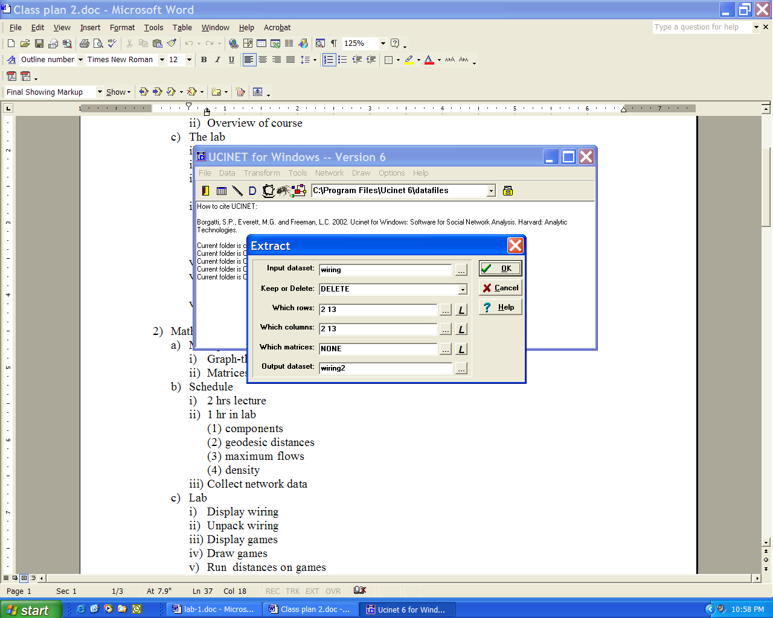

And obtain the following results:

EXTRACT
--------------------------------------------------------------------------------

Operation: DELETE
Rows: 2 13
Columns: 2 13
Relations: NONE
Input dataset: C:\Program Files\Ucinet 6\datafiles\wiring
Output dataset: wiring2

Matrix 1: RDGAM

1 1 1 1
1 3 4 5 6 7 8 9 0 1 2 4
I W W W W W W W W W S S
- - - - - - - - - - - -
1 I1 0 1 1 1 1 0 0 0 0 0 0 0
3 W1 1 0 1 1 1 1 0 0 0 0 1 0
4 W2 1 1 0 1 1 0 0 0 0 0 1 0
5 W3 1 1 1 0 1 1 0 0 0 0 1 0
6 W4 1 1 1 1 0 1 0 0 0 0 1 0
7 W5 0 1 0 1 1 0 0 1 0 0 1 0
8 W6 0 0 0 0 0 0 0 1 1 1 0 0
9 W7 0 0 0 0 0 1 1 0 1 1 0 1
10 W8 0 0 0 0 0 0 1 1 0 1 0 1
11 W9 0 0 0 0 0 0 1 1 1 0 0 1
12 S1 0 1 1 1 1 1 0 0 0 0 0 0
14 S4 0 0 0 0 0 0 0 1 1 1 0 0

…

What you have just done is to create a new dataset called Wiring2 that is just like the original except that it is missing the two nodes (I3 and S2).

10. Go to Data|Spreadsheet and open the Wiring2 dataset that you just created. Verify that I3 and S2 are gone.

11. Press the  button to start NetDraw. Press the Open File button and load the Wiring2 dataset. You should see this diagram:

