Lab 2

Graph-Theoretic Concepts

1. Start up UCINET 6

2. Set default folder to M:\datafiles using “file cabinet” button on far right.

3. Go to Data|Unpack and unpack the Wiring dataset. This will create a series of datasets, one for each relation in the Wiring dataset. Here’s how to fill out the form:

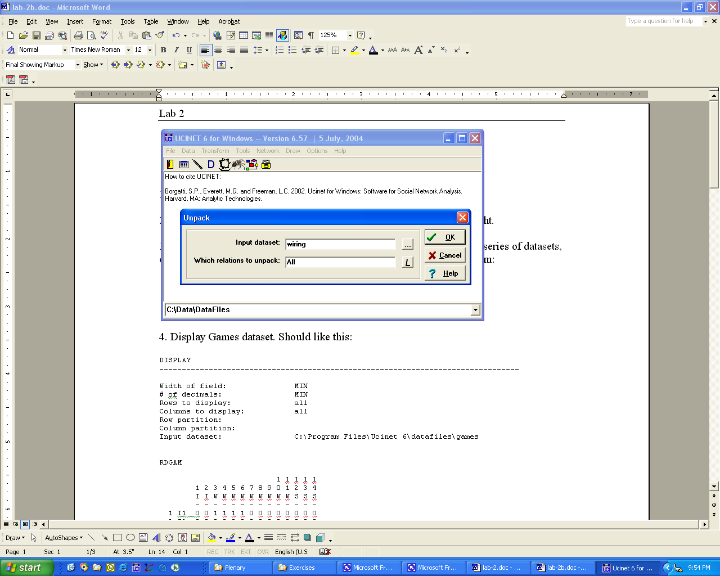

The output is mostly new datasets that you will find on the hard disk. However, the output log will tell you the names of the files created:

UNPACK MULTI-RELATION DATASET
--------------------------------------------------------------------------------

Input dataset: C:\Data\DataFiles\wiring

Creating the following datasets:
C:\Data\DataFiles\RDGAM
C:\Data\DataFiles\RDCON
C:\Data\DataFiles\RDPOS
C:\Data\DataFiles\RDNEG
C:\Data\DataFiles\RDHLP
C:\Data\DataFiles\RDJOB

----------------------------------------
Running time: 00:00:01
Output generated: 12 Jul 04 21:58:34
Copyright (c) 1999-2004 Analytic Technologies

4. Display “rdgam” dataset created in the step above. Should look like this:

DISPLAY
--------------------------------------------------------------------------------

Width of field: MIN
# of decimals: MIN
Rows to display: all
Columns to display: all
Row partition:
Column partition:
Input dataset: C:\Program Files\Ucinet 6\datafiles\games

RDGAM

1 1 1 1 1
1 2 3 4 5 6 7 8 9 0 1 2 3 4
I I W W W W W W W W W S S S
- - - - - - - - - - - - - -
1 I1 0 0 1 1 1 1 0 0 0 0 0 0 0 0
2 I3 0 0 0 0 0 0 0 0 0 0 0 0 0 0
3 W1 1 0 0 1 1 1 1 0 0 0 0 1 0 0
4 W2 1 0 1 0 1 1 0 0 0 0 0 1 0 0
5 W3 1 0 1 1 0 1 1 0 0 0 0 1 0 0
6 W4 1 0 1 1 1 0 1 0 0 0 0 1 0 0
7 W5 0 0 1 0 1 1 0 0 1 0 0 1 0 0
8 W6 0 0 0 0 0 0 0 0 1 1 1 0 0 0
9 W7 0 0 0 0 0 0 1 1 0 1 1 0 0 1
10 W8 0 0 0 0 0 0 0 1 1 0 1 0 0 1
11 W9 0 0 0 0 0 0 0 1 1 1 0 0 0 1
12 S1 0 0 1 1 1 1 1 0 0 0 0 0 0 0
13 S2 0 0 0 0 0 0 0 0 0 0 0 0 0 0
14 S4 0 0 0 0 0 0 0 0 1 1 1 0 0 0

6. Run Network|Cohesion|Distance. Use Games as the input dataset as follows:

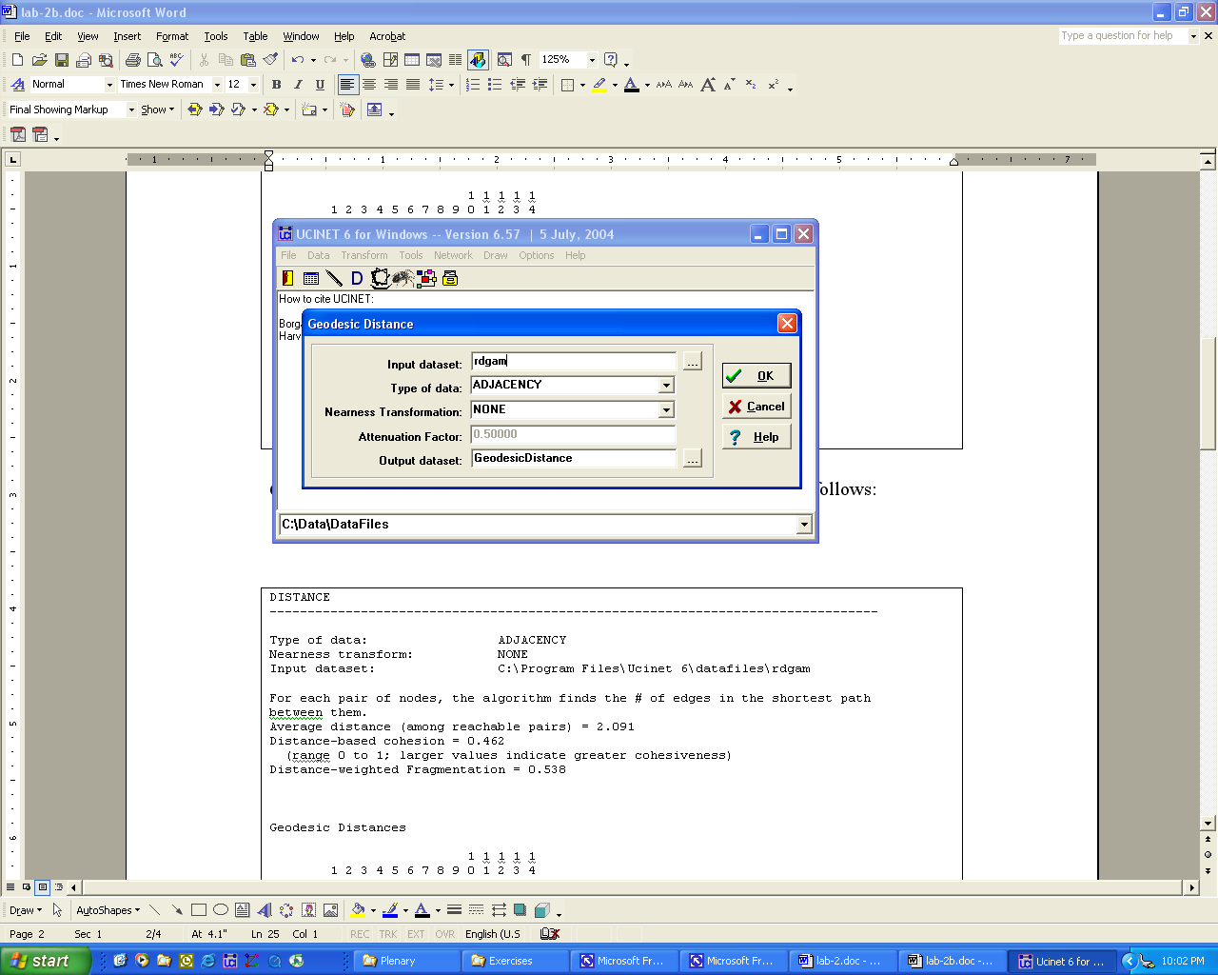

The output should be this:

DISTANCE
--------------------------------------------------------------------------------

Type of data: ADJACENCY
Nearness transform: NONE
Input dataset: C:\Program Files\Ucinet 6\datafiles\rdgam

For each pair of nodes, the algorithm finds the # of edges in the shortest path
between them.
Average distance (among reachable pairs) = 2.091
Distance-based cohesion = 0.462
(range 0 to 1; larger values indicate greater cohesiveness)
Distance-weighted Fragmentation = 0.538

Geodesic Distances

1 1 1 1 1
1 2 3 4 5 6 7 8 9 0 1 2 3 4
I I W W W W W W W W W S S S
- - - - - - - - - - - - - -
1 I1 0 1 1 1 1 2 4 3 4 4 2 4
2 I3 0
3 W1 1 0 1 1 1 1 3 2 3 3 1 3
4 W2 1 1 0 1 1 2 4 3 4 4 1 4
5 W3 1 1 1 0 1 1 3 2 3 3 1 3
6 W4 1 1 1 1 0 1 3 2 3 3 1 3
7 W5 2 1 2 1 1 0 2 1 2 2 1 2
8 W6 4 3 4 3 3 2 0 1 1 1 3 2
9 W7 3 2 3 2 2 1 1 0 1 1 2 1
10 W8 4 3 4 3 3 2 1 1 0 1 3 1
11 W9 4 3 4 3 3 2 1 1 1 0 3 1
12 S1 2 1 1 1 1 1 3 2 3 3 0 3
13 S2 0
14 S4 4 3 4 3 3 2 2 1 1 1 3 0

Distance matrix saved as dataset GeodesicDistance

----------------------------------------
Running time: 00:00:01
Output generated: 08 Jul 03 08:42:33
Copyright (c) 1999-2000 Analytic Technologies

Note that some distances could not be computed. This is because the network is disconnected – there are two isolates.

7. Verify the disconnectedness of the network by using NetDraw to draw a picture of RDGAM. (In Ucinet, press the Netdraw button. When Netdraw starts up, press open file button and select rdgam.) You should get this:

Note the two isolates at the top left.

8. Run Network|Regions|Components|Simple graphs. Use RDGAM as the input dataset. The result shows 3 components. In addition, the end of the output indicates that a dataset called InMainComp was created.

COMPONENTS
--------------------------------------------------------------------------------

Input dataset: C:\Program Files\Ucinet 6\datafiles\rdgam

Kind of Components: WEAK

3 components found.

NODE COMPONENT
I1 1
I3 2
W1 1
W2 1
W3 1
W4 1
W5 1
W6 1
W7 1
W8 1
W9 1
S1 1
S2 3
S4 1

Components with 3 or more members:
1: I1 W1 W2 W3 W4 W5 W6 W7 W8 W9 S1 S4

Component size heterogeneity: 0.255
Normalized heterogeneity: 0.275
Entropy: 0.509
Normalized entropy: 0.193
Fragmentation: 0.275

Component-by-actor indicator matrix saved as dataset Components_Sets
Partition vector saved as dataset Components_Partition
Main component indicator vector saved as dataset InMainComp

----------------------------------------
Running time: 00:00:01
Output generated: 08 Jul 03 08:43:59
Copyright (c) 1999-2000 Analytic Technologies

9. Display InMainComp to understand what it is. It looks like this:

1
M
-
1 I1 1
2 I3 0
3 W1 1
4 W2 1
5 W3 1
6 W4 1
7 W5 1
8 W6 1
9 W7 1
10 W8 1
11 W9 1
12 S1 1
13 S2 0
14 S4 1

The file is a column vector of 1s and 0s. A 1 indicates that the node is a member of the main component and a 0 indicates that the node is not a member of the main component.

10. Use InMainComp to extract the main component of Games as follows. Go to Data|Extract. Fill out prompts as follows:

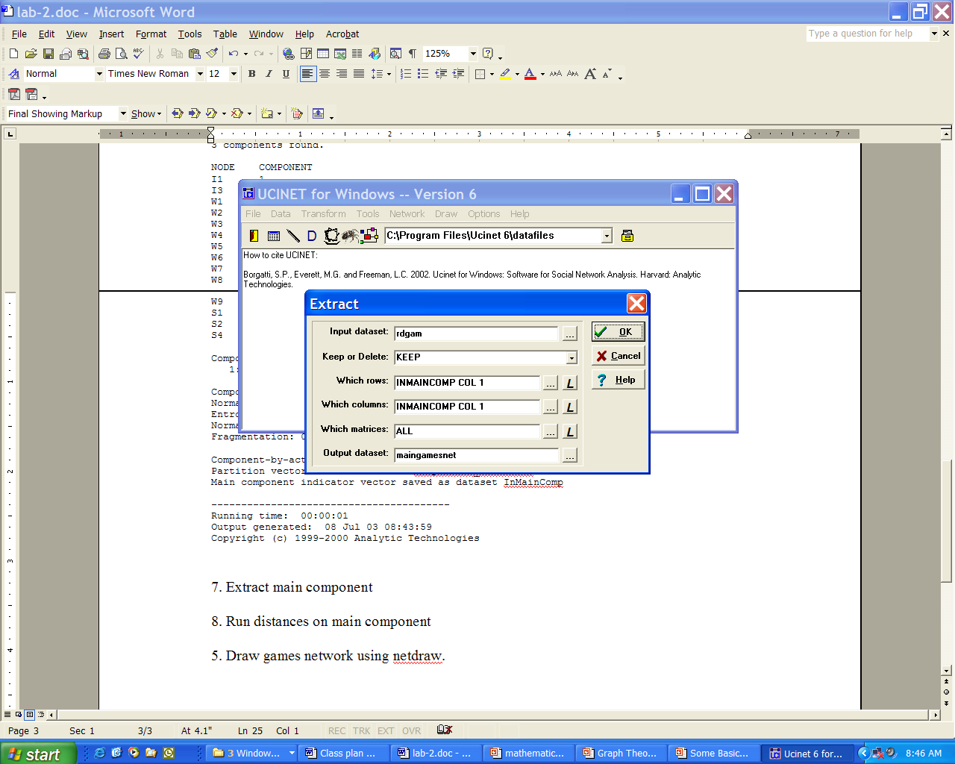

11. Use Network|Cohesion|Distance to obtain geodesic distances on MainGamesNet. Verify that all distances are now computable.

12. Run Network|Cohesion|Maximum Flow on MainGamesNet. Can also run on RdGam for comparison.

13. Run Network|Cohesion|Point Connectivity on MainGamesNet (can also run on RdGam for comparison).

14. Run Network|Regions|BiComponent on MainGamesNet.

15. Run Network|Network Properties|Density on MainGamesNet and RDGAM.

