The Evolution of Networks in Extreme and Isolated Environments*

Jeffrey C. Johnson
East Carolina University

James S. Boster
University of Connecticut

Lawrence Palinkas
University of California San Diego

This article reports on the evolution of network structure as it relates to the formal and informal aspects of social roles in well bounded, isolated groups. Research was conducted at the Amundsen-Scott South Pole Station over a 3-year period. Data was collected on crewmembers’ networks of social interaction and personal advice over each of the 8.5-month winters during a time of complete isolation. In addition, data was collected on informal social role structure (e.g., instrumental leadership, expressive leadership). It was hypothesized that development and maintenance of a cohesive group structure was related to the presence of and group consensus on various informal social roles. The study found that core-periphery structures (i.e., reflecting cohesion) in winter-over groups were associated with the presence of critically important informal social roles (e.g., expressive leadership) and high group consensus on such informal roles. On the other hand, the evolution of clique structures (i.e., lack of cohesion) were associated with the absence of critical roles and a lack of consensus on these roles, particularly the critically important role of instrumental leader.

Keywords: network evolution, core/periphery structure, informal roles, role consensus

Introduction
A number of researchers have begun to recognize the increasing importance of broader sociological, anthropological, and social psychological issues in the study of humans in insolated and extreme environments, particularly with respect to the social complexity of larger groups (Johnson and Finney, 1986; Harrison and Connors, 1984; Nicholas et al., 1988; Pierce 1985). Most notable among the potential concerns are the relationship of structural concepts such as position, status, role, and norms to group evolution and function. Harrison and Conners (1984) have pointed out that little actual research employing structural theory and concepts had been carried out prior to their review. This is still basically true today.
The absence of the application of structural concepts in earlier work on social groups is somewhat understandable, since much of it has involved less than seven participants (Johnson and Finney, 1986). Even in research on larger groups in exotic environments such as polar research stations and among submariners, most of the attention has focused on questions of health and psychological well-being (c.f. Gunderson, 1974; Gunderson and Palinkas, 1991; Taylor, 1987) with little attention to the social, cultural, or social psychological issues. Structural concepts begin to increase in their explanatory value as groups become larger than seven. This number is the upper limit (5±2) for the size of a single clique (Killworth and Bernard, 1974). Beyond this limit, groups have the potential to form multiple cliques or subgroups, thereby increasing structural complexity. One of the few early examples of the application of structural concepts to a study of groups in exotic environments is Smith’s (1966) sociometric study of an Antarctic work group. In this study, seven members of a single work expedition were observed and interviewed. Thus, one of the few applications of structural concepts to research in exotic environments was somewhat limited in terms of structural complexity. Johnson (1989) and Nicholas et al. (1988) have highlighted the importance of structural considerations in research concerned with crew selection, training, and team development for future space missions. The point is that in larger, more complex groups, structural factors become difficult to ignore (Johnson and Finney, 1986).
Weak leadership in polar expeditions has been associated with catastrophic failure (Leonov and Lebedev, 1975), and with low morale in other isolated settings (Hammes and Osborne, 1965). Leadership has been one of the most intensely studied aspects of small group phenomena, producing a vast array of definitions, a variety of methods for identifying or evaluating individuals in example, the difference between the “functions” approach of Goudan (1970), which emphasizes the characteristics of leaders, and the “integrative” approach of Gibb (1969), which emphasizes leader-follower relations.
Many distinguish between “instrumental” or “task-motivated” leaders who are focused on the accomplishment of goals, and “expressive” or “relation-motivated” leaders who play more solidarity building roles in a group (Bales, 1953, 1958; Bales and Stodtbeck, 1955; Hare, 1976; Slater,1955; Bales and Slater, 1955; Fiedler, 1971; Rees and Segal, 1984). Termed “role differentiation theory,” it has been criticized because it fails to consider the integration of the two leadership roles into one (Lewis, 1972; Meeker and Weitzel-O’Neil, 1977). House (1977), too, questions the mutual exclusivity of these roles in that the most successful groups tended to be those in which leadership roles were integrated, rather than differentiated. Such leaders were termed “charismatic.”
The literature on leadership also demonstrates the importance of the distinction between informal (emergent) and formal group structure. As Smith (1966) noted in observations of an Antarctic group, informal or emergent roles will often replace or supplement more formal roles. During the course of selecting expedition members for his attempt at the South Pole, for example, Amundsen was painstakingly aware of the potential problems associated with the fit between informal and formal role structures. Purposely keeping the backgrounds of member homogeneous, thereby avoiding the problems associated with background heterogeneity (e.g., scientists vs. non-scientists), Amundsen devised an ad hoc test of potential members’ stance toward authority. As reported in Huntford (1984), Amundsen tested potential members with intentionally obscure work tasks. The task simply tested an individual’s potential competition for Amundsen’s role as leader. If someone in the course of the test questioned his authority, the individual was eliminated from consideration.
Palinkas (1989c, 1990) and Blair (1992) observed that effective leadership appears to be based on prior experience, articulation of goals, flexibility, and degree of interaction with other winter-over personnel. Data obtained on leaders of previous Antarctic winter-over crews indicated that evaluations of effective leadership were based on the ability of individuals assuming these roles to minimize group conflict, effectively address problems such as abusive or alcoholic station members before they began to affect station morale, keep projects on schedule without overworking personnel, make clam and rational decisions during an emergency, be fair and impartial particularly in conflicts between navy and civilian personnel), and maintain a certain level of communication with other winter-over personnel through work-related and social activities without becoming too “chummy.” Leaders lacking these abilities were harshly criticized and blamed for low moral, group conflict, and inability to successfully complete projects with a minimum of mistakes.
“Leaders” and “followers” are labels for two major “statuses,” or “group positions,” but, as we saw previously, it is important to realize that here may be informal or covert statuses that are not so easily identified. Formal status terms do not always cover the range of statuses and roles found in groups (Goodenough, 1969; Merton, 1957).
“Too many cooks…” and “too many chiefs…” are folk sayings that capture the essential point that group heterogeneity is important and that competition for leadership should be kept at a minimum. Furthermore, the relations among the statuses must be viewed as a “structure.” Their development within a group is initially determined by the degree of fit between members of the group and their ability to come to an agreement on the status and role of each member.
In a particularly interesting situation of this principle, Klein and Christiansen (1969) analyzed the relative effectiveness of basketball teams as a function of variation in role expectations, status consensus, achievement motivation, and focused leadership. Teams that have both high average achievement motivation and high variance in achievement motivation tend to have higher status consensus, display higher degrees of group cohesion, and therefore, win more often. They also found that variations on the task-orientation of the players increased the chances that differing role expectations would be met. Roberts has obtained similar results for groups in a variety of competitive situations, including the military(Roberts and Wicke, 1971; Roberts et al., 1972; Roberts et al., 1980), drivers (Roberts and Kundrat, 1978), and athletes (Roberts and Nuttrass, 1980).
Early on, Hall (1955) recognized the crucial importance of members’ agreement on group roles for producing cohesive groups. In the absence of role consensus, we find “role collision,” described by Hare (1976) as a “type of conflict with may occur if two different individuals in a group perform roles which overlap in some respects.” Heterogeneity on some dimensions can produce effective groups by simply reducing the potential for role collision. The value of status and role heterogeneity is counterposed by the potential corrosive effect of heterogeneity among group members’ backgrounds (e.g., nonscientists vs. scientists) and other characteristics (Palinkas, 1989a: Johnson and Finney, 1986; Bernard and Killworth, 1973).
The Amundsen example also illustrates the importance of structural heterogeneity; varying the structural characteristics of group members allows them to fit in and function well with each other. By screening the structural or role characteristics of possible expedition members Amundsen minimized the potential for conflict due to role collision. This contention is reinforced by reexaminations of Bavelas-type experiments by Freeman et al. (1979), which show the relationship between effectiveness and centrality (itself an indicator of heterogeneity) and by the work of MacKenzie (1976) demonstrating relationships between group hierarchy, task processes, and group efficiency.
Note that status and role heterogeneity does not simply refer to heterogeneity of personality traits. Individual needs for communication, interaction, and reinforcement from their environment support good morale and individual effectiveness; individuals must fit in with one another. In basketball, “fitting in” is determined by the networks formed by passing the ball. As Klein and Christiansen (1969) demonstrated, structural heterogeneity resulted in effective communication and efficient ball passing. We would also expect to find relationships among the variance in achievement motivation, the production of an optimal network structure, and finally, performance.
Outside of the psychotherapy literature, there have been few studies of deviant or lower social statuses within small groups. Earlier small research focused on the negative aspects of deviants in lower statuses, in particular, on their non-conformity and rejection by the group (Newcomb, 1943; Chowdry and Newcomb, 1952; Festinger, 1954; Riecken, 1952; Israel, 1956). Similar findings for groups in exotic environments have been reported (Harrison and Connors, 1984).
Others, however, have recognized the positive aspects of such stigmatized statuses by noting the important functions of deviants or low status individuals (Dentler and Erickson, 1959; Johnson and Miller, 1983). Deviant roles emerge in many enduring groups, especially those in isolation (e.g., work groups [Dentler and Erickson, 1959]; Antarctic exploration groups [Johnson and Finney, 1986], and isolated commercial fish camps [Johnson and Miller, 1983]). The deviants in these examples positively function to promote group cohesion, reduce boredom, and inhibit group conflict. Dentler and Erickson (1959) point out that deviance is not only a natural part of group structure, it is institutionalized, accepted, and rewarded.
The positive functional aspects of such low status positions can make a considerable contribution to producing harmonious and effective small groups. Just as “charismatic” leadership (House, 1977) is important, so too is the presence of “charismatic” deviance (Johnson and Miller, 1983). Occupants of such a social position will function in roles that provide a common reference point (e.g., mascot) for all other group members, thereby promoting group cohesion. This role will typically manifest itself in humor and joking behavior. As Earls (1969) and Dunlap (1965) point out, such behavior is essential for coping with boredom brought about by prolonged periods of isolation.
In the Antarctic, Palinkas (1989a, 1992a), identified two major categories of deviants in American winter-over crews. The first category is the individual who fails to conform to group norms and expectations. These include individuals who break rules regarding personal or group safety, resulting in injury or death, which affect the morale of the entire station; individuals who abuse alcohol and become hostile to other crewmembers or fail to perform their work assignments; individuals who fail to perform routine duties such as housekeeping; and individuals in positions of authority who fail to exercise leadership or fulfill group expectations of the leadership role. Although these individuals serve to unify the group as a whole by serving to define the boundaries of acceptable and unacceptable behavior and reinforce group norms, they may also serve to weaken morale and lead to wider social conflict if little or nothing is done to control their behavior or minimize its effects on other group members.
The second category of deviant is the individual who acts as the station clown or jester. Frequently, this person is the cook, a civilian contractor employee, or a junior enlisted Navy man who will perform pranks and exaggerate his or her behavior sufficiently to be outside the mainstream of behavior on the station, yet not enough to be considered disruptive or threatening. This behavior provides a certain measure of relief to the stress imposed by the monotony of the physical and social environment. These individuals also provide an important communication function in that they are frequently allowed to express frustrations or dissatisfaction with disruptive individuals or undesirable conditions in a socially acceptable manner without causing additional stress or conflict.
There is abundant anecdotal evidence that lower social statuses have been important in past Polar expeditions. For instance, on his Antarctic expedition, Amundsen brought with him a cook named Lindstrom. As “Chef, baker, pastry-cook he provided surrogate domesticity. He was also instrument maker, taxidermist, housepainter…and clown (334).” In his marginal social position as cook, Lindstrom provided not only food, but also humor and comic relief, and greatly contributed to group harmony during the long winter. Because of his marginal position, Lindstrom was able to play the role of clown or court-jester without fear of any sanctions. Thus, interpersonal and intraclique tensions and conflicts were reduced by the inclusion of this single member.
In a study of Italian commercial fishermen in an isolated camp in Alaska, Johnson and Miller (1983) and Johnson and Finney (1986) described the example of a deviant member (i.e., the worst fisherman of the group) who helped to mitigate conflict between the two major cliques within the network of fishermen. During the fishing season of 1980, a strike had idled most of the fishermen in the camp. This was a period of boredom, high stress, and high potential for inter-personal and inter-clique conflict. However, the deviant, because of his status and personal characteristics, emerged in the role of “court jester,” providing comic relief and a common reference point for all group members irrespective of subgroup affiliation. They made fun of him, played pranks on him, and he was a fun topic of conversation. He was rewarded for his role and received valuable salmon as compensation. He maintained moderate proximities among members of both cliques. His role was important in minimizing conflicts during this tense period. As other group members described him: “He is the bridge between the two groups,” and “He belongs to everyone,” (Johnson and Miller, 1983:67).
Another important aspect of group structure concerns its formation and stability. Palinkas (1989a) noted three distinct stages of group formation among Antarctic groups: group openness, subgroup formation, and the formation of group identity. In this process, the group goes from incoherent to coherent structure in the first two phases, while in the third phase, the group develops shared norms and group identity (e.g., winter-over vs. non-winter-over personnel). Much of the development of this identity is facilitated by a social comparison process between group members and those from the “outside” (Natani and Shurley, 1974; Palinkas, 1992a); perceived similarity between two members of a network is directly related to their competition either with each other or some third party (Burt, 1982; Johnson, 1986).
Whereas such a comparison process often leads to homogeneity in group norms, values, and the development of a group identity, it may also lead to conflict. Conflict is viewed as a fundamental to social interaction among members of small, isolated groups in the Antarctic (McGuire and Tolchin, 1961; Natani and Shurley, 1974; Palinkas, 1989b; Palmai, 1963; Taylor, 1974), and is believed to occur in three distinct stages that parallel the stages of group formation. During the first stage, conflicts occasionally occur between subgroups of station members. At McMurdo, this conflict often occurs between military and civilian crewmembers, while at South Pole differences between scientific and civilian support personnel occur. Conflicts also occur on the basis of differences in occupational assignments (seabees versus administrative/clerical personnel, for instance) (Natani and Shurley, 1974), recreational preferences (“back to nature types” versus “couch potatoes”), extent of alcohol or substance abuse (Palinkas, 1989b), tastes in music (Strange and Youngman, 1971), and age (Taylor, 1974, 1987). During the third stage, the unified social group may be in conflict with individual crewmembers or cliques who are ostracized for failing to adhere to group norms. These include individuals who regularly abuse alcohol or other substances, fail to perform assigned tasks, are belligerent or violent when drunk, or jeopardize themselves or others through disregard to safety rules and regulations.
Although social conflict may be found to some degree in almost every winter-over crew, it is unclear whether this conflict is an inherent feature of the social, cultural, and environmental characteristics of the group itself (c.f., Rohrer, 1961), or is the result of differences in personality, social cognition, and of the sociocultural background or cultural milieu of individual group members (Palinkas, 1988, 1989b), the size of the social group (Doll and Gunderson, 1971), or style of leadership exercised by station managers or officers-in-charge (Biersner and Hogan, 1984). Some winter-over crewmembers at McMurdo Station in 1989, for instance, indicated that levels of social conflict tend to increase during years when the crew includes construction workers hired to complete certain jobs during the winter. A study by Biersner and Hogan (1984) found that social compatibility remained high during the nine months of confinement at one station whose leader received high ratings from other station members, while at a second station, whose leader received poor marks from fellow winter-over personnel, conflicts among members of the group were frequent and severe.
Furthermore, it is unclear whether social conflict is the cause or the consequence of an individual failure to adapt to the unusual social and environmental conditions of the Antarctic research station during the austral winter. For example, the inability to cope with the prolonged confinement with undesirable co-workers and isolation from family and friends back home may lead to increased alcohol abuse, which, in turn, increases the risk of fighting between individuals. On the other hand, conflicts with co-workers or other station members may lead to emotional distress, reduced morale, and a decline in work performance.
Research focusing on the evolution of network structure (Doreian 1983) and its relationship to group function and conflict is critical for understanding the dynamic interplay between role and network structures and, more importantly, group outcomes (e.g., performance) in well bounded networks. Romney et al. (1989) discussed models of longitudinal network data in a reexamination of the Newcomb data. They found that the structure of the group converged quickly to a stable final structure. Others, too, have been concerned with statistically modeling stability in social networks over time, particularly in fixed node networks (Snijders 1990; Sanil, Banks, and Carley 1997) . Yet others have looked for possible explanations underlying stability or change including such things as reciprocity, tie strength, transitivity, and structural embeddedness (Feld 1997). However, there has been little work relating changes in network structure to the characteristics and structure of social roles found in groups.

Propositions
Based on the literature discussed above we might expect the evolution of cohesive group structure to be related to the emergence of and agreement on various informal social roles. We specifically explore the following propositions as they relate to the evolution of network structure over time:
P₁: The more the consensus on informal leadership roles, the more cohesive the group, independent of initial conditions.

P₂: The more that informal and formal leadership roles overlap, the more cohesive the group, independent of initial conditions.

P₃: The more the consensus on expressive leadership roles, the more cohesive the group, independent of initial conditions.

P₄: The more that instrumental and expressive leadership roles are integrated, the more effective will be the leadership and the more cohesive the group.

P₅: The more that positive deviant roles are present, the more cohesive the group.

We examine these propositions in a setting that allows for clear network boundaries and little influence from factors outside the network of interest. Often termed a “natural” laboratory for the study of humans in isolation, the South Pole Station is the setting for an examination of the propositions.
The Setting
The setting for this study is the Amundsen-Scott South Pole Station located 90º South Latitude. An American station, the site has been occupied since the International Geophysical Year in 1956. The original polar station was abandoned in the early seventies being replaced by a larger station whose most prominent feature is a large geodesic dome that provides protection for a number of modular buildings.
The station is run by the National Science Foundation and its primary purpose is concerned with scientific investigation in various fields, most notably astrophysics. Although initially the polar crews at South Pole included both civilian and Naval personnel it is now exclusively a civilian operation (with the exception of C-130 flights in and out of the pole piloted by the military). Winter over crews consist of two primary groups of people. First, there are the support personnel (referred to here as “trades”) who work for a private firm contracted to run the day-to-day operations of the station. These include plumbers, carpenters, electricians, mechanics, cooks, material handlers, science and computer techs, and the station manager. Second, there are the NSF grantees and their employees (grad students, science technicians, post-docs), often referred to by the “trades” personnel as “beakers”.
There are a number of ethnographic background items that are important for understanding the overall analysis and discussion:
- Crew members beginning training as a group in August preceding the month of deployment to the South Pole in October. They are in each other's company for well over 16 months.
- Winter over crew are generally at the South Pole Station from October of one year through November of the next. Technically, an individual is not allowed to stay two successive winters.
- Winter over crew are confined to the station for 8.5 months during the Austral winter with no crew leaving or no new crew entering. The nearest American station (McMurdo Station) is over 800 miles away. Winter temperatures are so cold (record temperature at South Pole –119º F) that rescue of crew is next to impossible.
- Joking behavior and pranks are an important part of station culture. Also referred to as “button pushing”, crew are often assessed by other crew on individuals’ ability to both give and receive such behaviors. Often pranks are on the edge of what might be considered to be in “jest” verging on what can be termed as mean spirited.
- There is a high degree of variation from year to year with respect to problems associated with the consumption of alcohol. Over the course of the three years of our research alcohol problems were generally isolated to single individuals rather than any particular group.
- The increase in the proportion of female crew at the station over the past 15 years has had a claming effect on both the incidence of “pranks” and on the frequency of “dome” mouth (foul language).

The Data
The network data for this study was collected over a three year period with three distinct winter-over crews in the 1990's at the Amundsen-Scott South Pole Station. Year A had a total winter over crew of 28 with 9 females and 19 males. Year B had a total winter over crew of 27 with 20 males and 7 females. Finally Year C had a total winter over crew of 22 with 4 females and 18 males. Winter-over crew members were the focus of the inquiry and most of the data reported here is for the 8.5 month winter-over period. During this period crew members were in complete isolation with no one coming in or leaving the station between approximately February 15 and October 25 of a given year. During the 15th of each of the 8.5 month isolation period the station physician distributed and collected questionnaires that asked a number of network and social-psychological questions. For the purposes of this paper we focus on two primary types of data collected during this period.
The first of these are crew members self reports of ratings of social interactions with each of the n-1 other crew members over the prior two weeks. The ratings scale ranged from 0 to 10 with 0 representing no interaction and 10 representing a great deal of interaction. These were collected at the middle of each winter-over month for a total of 8 months. Finally, additional network data was collected at station opening at the end of October. This consisted of successive pile-sorts of crew perceptions of "who people hung out with".
The second primary type of data consisted of a sentence frame completion task (Johnson and Weller, forthcoming) asking crew members to associate each of the crew, including themselves, with each of eleven possible informal social roles. Crew were asked to circle all the names that fit a sentence such as "__________ is a natural leader in getting things done around station." This task was collected at the beginning, middle and end of the period of winter-over isolation. In addition, and in conjunction with the successive pile-sorts, crew were asked at station opening to associate crew members with each of 22 different informal social roles or role attributes. This differed from the eleven informal roles used in the questionnaire described above in that an additional set of more negative roles were included. The positive informal roles/role attributes included social director, leader, everybody's buddy, peacemaker, joke with, comedian/clown, storyteller, counselor, count on, committed to work, and volunteer. The more negative informal roles/attributes included self-exile, loner, rigid, cliquey, disruptive, know-it-all, whiner, hypertense, and alcohol problem. These informal roles and role attributes were obtained from a set of preliminary interviews with winter-overs from years previous to the beginning of the 3 year study (see Johnson and Weller, forthcoming for a description of the methodology).
For our purposes we focus primarily on three informal roles. The first of these we refer to as the instrumental leadership role and is associated with the elicitation frame referring to “a natural leader in getting things done around station”. The second is the expressive leadership role and is defined as individual crew who were viewed as “social directors” and organizers of events. The final roles concern positive deviance (i.e., clowns and comedians) and negative deviance (i.e., the negative roles listed above).

Core/Periphery Structure

Initially, we need to examine the degree to which each of the years has a core/periphery structure or more precisely the extent to which a core/periphery structure evolves and remains stable over time. We accomplish this in two ways. First, network graphs of the of the social interactions ratings for each of the months and the successive pile sort data collected at station opening will provide a visual test of the presence of core/periphery structures in the groups. Second, based on the recent work of Borgatti and Everett (in press) we employ the core/periphery block model approach which seeks to maximize the correlation between a structure matrix representing a theorized core/periphery structure and a partitioning of the raw data itself.
Figures 1-3 show the final group structures (i.e., at station opening at the end of October) for each of the three years as shown in a multidimensional scaling of the successive pile sort data of crew's perception of "who hung-out with whom". A visual inspection of the three configurations reveals that Year A (Figure 1) has what might be thought of as a classic core/periphery structure with the core members interacting frequently amongst themselves and peripheral members having less interaction with either the core or other periphery members. Year B (Figure 2) has some the same characteristics as Year A, but has three actors in the periphery (one is D an extremely shy individual and two not shown who were in self-exile further from the core) and a core that contains some degree of subgrouping based on higher interaction frequency for some in the core versus others. From the interviews (i.e., circled subgroups are based on distinctions made by crew and not by any computational means) three of the major subgroups within the core consist of a group that hung out a lot in the galley and was referred to as the "couch group" (a mix of both science and trades crew members). A second group within the core consisted of three individuals who worked the night shift while the third major subgroup consisted of couples of which several had previous winter-over experience. Year C (Figure 3) stands in stark contrast to the previous two years in that there is a clear clique structure in which three distinct subgroups are evident, subgroups that had a tendency to hangout with one another in three separate and distinct locations within the station (e.g., location of tvs and vcrs). In addition, there are a number of crew that lie between the three subgroups and one clear outlier.
In a further examination of the evolution of core/periphery structures in the three years we now turn to the monthly reports of rates of social interaction. Although we shall see other sections of the paper that will contribute further to an understanding of various types of change in the networks over time, we now look at the degree to which core/periphery structure changed over the course of the entire year for each group. An indicator of core/periphery structure comes from Borgatti and Everett (in press) and is based on the idea of a sorting actors into core and periphery blocks in which the upper left block of the model will contain actors with high frequencies of interaction and the lower right block will contain peripheral actors with low frequencies of interactions or near zero interactions. The indicator of core/periphery is obtained through correlating (QAP correlations) a theorized structure matrix (i.e., containing all ones in the upper left block and all zeros in the lower right block) with the blocked raw interaction data. The core/periphery index, referred to as "final fitness", was calculated using the core/periphery categorical procedure in UCINET V (Borgatti 1999).
Figure 4 shows the change in final fitness over the 8.5 months of winter for the three groups. The three years show varying degrees of similarity in change over course of the winter. Whereas all three years show a decline in fitness for the last month of the winter, Year C shows an overall decline in fitness over the course of the winter while Year A shows an overall increase. Year B, on the other hand, shows a periodic up and down movement with little net gain or loss over the course of the 8.5 months. The decline in fitness for all three in the last month may reflect the overall decline of social interactions among crew more generally given the need to concentrate on work issues in anticipation of station opening. All three experience lowest fitness in the midwinter period. This seems to correspond well with other psychological indicators in which midwinter often is the time that crew experience the greatest amount of depression and the greatest problems due to the effects of seasonal affective disorder due primarily to light deprivation (Palinkas et al. 1998).
Both the visual and block model methods for determining core/periphery structure in the three years ultimately agree that Year A displays the greatest core/periphery structure, followed by Year B and Year C at winters' end. It is important to note the radical changes in the fitness for Year C. As we shall see in later sections, this is in keeping with a number of problems faced by members of this group over the course of the winter.
Direction of Change
As we saw in the section above, two of the years experienced change with respect to fitness in either an upward or downward direction. Such changes in structure imply some degree of directionality in movement over time. For example, one would anticipate Year A to move from a structure that is less cohesive to one that is more cohesive. On the other hand, the analysis above implies that Year C moves from a structure that is more cohesive to one that is less cohesive. Finally in the analysis above Year B may display shifts of individuals over time but not any real change overall in the final structure as compared to it's initial structure.
Figures 5-7 show the results of a series of Correspondence Analyses of the stacked interaction ratings matrices over the 8.5 month period. For each of the figures only the initial position and final position for each crew member is shown. The arrows indicate the direction of the movement for each crew member from March to October. A characterization of the movements corresponds well with what was implied from the analysis on fitness. Year A , with a few exceptions, has most crew moving inward toward the center of the space. For Year B movement is somewhat mixed with many crew moving position in the same relative direction while others moving only slightly in the opposite direction. Finally, Year C, again, stands in contrast to the other two in that there is a clear movement of crew members outward from the center of the space to the periphery of the space in a kind of structural supernova. In addition, the movement of clusters of crew in basically three different directions reflects the formation of well defined subgroups reflected in the MDS of the successive pile sort data.
Table 1 attempts to summarize the movement of actors in each of the 3 years. Based on a visual inspection of the plots, counts were made as to whether actors were moving toward each other in the center of the space or away for each other. Although there may be some degree of subjectivity in assigning direction there is an obvious trend that is illustrated by the table. Year A has the most movement inward followed by Year B. Year C moves from a more cohesive core/periphery structure to one that is much more factionalized into relatively distinct subgroups.
Evolution and Instrumental and Formal Leadership

In this section we examine the propositions concerning the relationships between group structure and the corresponding evolution of social roles. In the first two propositions (P₁) we expect a cohesive group structure to be associated with both group consensus on instrumental leadership (i.e., informal work leader) and the overlap of informal instrumental leadership with formal designated leadership (P₂). We must look for such relationships, however, in a more descriptive or exploratory manner given we lack a sufficient number of cases to conduct any reasonable statistical tests of the propositions. Nevertheless, a visual examination of the data should reveal general trends if, in fact, they are present.
Table 2 is shows changes in the degree of consensus on the instrumental leadership role between the beginning and end of winter. Strong consensus is considered to be 67 percent or more of those responding assigning a role to a given individual (c> .66). Moderate consensus is agreement among those responding ranging between 33 and 66 percent (.33<c<.67). The table reveals two important trends that are both in the predicted direction. First the two most cohesive years move from lack of consensus on instrumental leadership to one of strong consensus and it should be noted that for Year A 100 percent of those responding agreed on the formal leader (i.e., the station manager) as the informal instrumental leader. On the other hand, Year C moves from consensus to divided agreement on instrumental leadership. More importantly, however, is the trend toward both agreement on and the overlap of both formal and informal leadership roles for Years A and B as compared to year C. In the former two years agreement on instrumental leadership increases over time and the formal leader, the station manager, exclusively occupies both informal and formal leadership roles. For Year C the movement is just the opposite. At the beginning of the winter there is strong consensus on and overlap between the informal and formal in terms of leadership. However, by the end of the winter there is competition between the formal leader and two other crew for the instrumental leadership role leading to role "collision". This corresponds well with the movement from a more core/periphery structure with the manger as the clear informal leader to a clique structure with competition between multiple informal leaders towards the end of the winter.
To help in illustrating the differences in final group structures in relation to the consolidation of both formal and informal leadership roles Figures 8-10 are graphs of the October (winter's end) network structures from the correspondence analysis of stacked matrices with formal leaders (station managers) distinguished as white vertices. The social interactions ratings data for each of the years was dichotomized using the following criteria.

1, if r > 4
X_{ij} =
0, otherwise

The graphs are in keeping with the discussion above in that for Year A (Figure 8) the manager is positioned in the center of the network surrounded by a high degree of interaction in the core. In Year B (Figure 9) the formal leader is in the center of the network encircled by a slightly less dense core as compared to the previous year. Finally, in Year C (Figure 10) the formal leader is central to one of the three main subgroups found in the network, but not in a position that fosters access to all segments of the groups structure.
Evolution and Expressive Leadership
Although possibly not as critical as instrumental leadership in groups, and as noted in earlier sections, expressive leadership is also important for positive group function. In addition, it is important to examine the relationship between group outcomes (e.g., cohesive structure) and the integration of both expressive and instrumental leadership roles in one (House 1977). Table 3 provides data on the changes in consensus on expressive leadership over the course of the winter. In a test of P₃ we observe Years A and B moving from a lack of expressive leadership to the presence of expressive leadership, particularly for Year A. Year A has strong consensus on three individuals in the role of expressive leader with moderate consensus on two others. This year has multiple individuals in the expressive role without necessarily the presence of role integration (P₄). Year B goes from the total absence of expressive leadership to one of moderate consensus on two crew members, one of which is the station manager (i.e., integration of formal and instrumental and expressive roles). Although certainly far from definitive, it would seem that there is slightly more support for role differential theory over the role integration approaches advocated by, for example, House (1977).
Year C, on the other hand, moves from high consensus on one individual and moderate consensus on another, who also happens to be the station manager, to the complete disappearance of anyone occupying an expressive leadership role. Thus, in this year the important role of expressive leader, although initially present, is absent by winters end.

Evolution and Deviant Social Roles
Finally, P₅ is tested through an examination of the presence or absence of both positive (i.e., joker/clown or comedian) and negative (i.e., self-exile, loner, rigid, cliquey, disruptive, know-it-all, whiner, hypertense, alcohol problem) deviant roles in the three years at the end of the Austral winter. Table 4 shows the frequency counts for both positive and negative roles. Years A and B have a large number of positive deviant roles with little or no negative deviance, at least in terms of any strong to moderate consensus. In keeping with previous analyses, Year C has only one moderately agreed upon positive deviant role while there are two crew seen as disruptive playing more negative roles. Thus the two years with the more cohesive structures have a higher degree of positive or functional deviance while the least cohesive year has the highest amount of dysfunctional deviance.
Discussion and Summary
The three years vary in terms of the evolution of network structures over the 8.5 months of the winter. Year A has the highest fitness in terms of core/periphery structure at winters end. The structure for this year evolves over time going from a less cohesive to a more cohesive structure by station opening. Year B has the second highest fitness and follows a different structural pattern over the winter. In this case, the structure of the group displays some degree of periodicity in fitness having moderate cohesion at both the beginning and end of the winter. Finally, Year C moves from a highly cohesive structure at the beginning of winter to a more factionalized structure by winters end. Figures 8-10 of the final network structures also confirms the difference in the three years in terms of cohesiveness. These difference in the evolution and stability of networks over time make it clear that instability, although often thought of in negative terms, is neither positive nor negative but is more a matter of the kind and direction of change that occurs. For Year A instability is positive in the sense that change occurred in manner that led to the evolution of group cohesion over time. For Year C, on the other hand, instability had negative consequences in that the group moved from a cohesive to a divisive network structure over the course of the winter.
Agreement on work or instrumental leadership increases over time for years A and B and is diffused for year C (moderate agreement on multiple work leaders) reflecting competition among individual crew for the instrumental leadership role. More importantly, there is consolidation of both instrumental and formal leadership into a single role for Years A and B, while for Year C the opposite is the case. Expressive leadership roles disappear completely for Year C , while Year A has high consensus on multiple actors in that role and Year B has moderate consensus for two individuals in that role, including the station manager (i.e., a case of role integration).
At winter's end positive deviant roles, such as clowns or comedians, are present in years A and B, but mostly disappear for Year C (moderate consensus on one crew member). Instead, year C has the highest amount of dysfunctional roles found in the three years studied. This is important in that the events that transpired in Year C worked to undermine the ability of the formal leader to maintain the consolidation of both informal and formal leadership roles. This was further exacerbated by the disappearance of the only expressive leader sometime in the middle of winter ( due in part to harassment of the expressive leader by a marginalized crew member). Lack of multiple expressive leaders (i.e., multiple social directors) meant that there was a high degree of dependency on a single individual to perform this important role over the course of the entire winter. The efforts of some of the disruptive crew members (i.e., dysfunctional deviants) eventually led to the withdrawal of the expressive leader from overall group interaction. This made the formal leaders ability to maintain group cohesion much more difficult.
The importance of expressive leadership lies in the ability of individuals in these roles to bring people together in a variety of interactive social contexts (e.g., dinner parties, sporting events, role playing games, movie nights). In this setting higher rates of social interaction aid in limiting gossip, the formation of stereotypes, and the development of rumors, all potential contributors to conflict and division. There appears to be a clear advantage in having several individuals in the role of social director or expressive leader. Unlike the role of instrumental leader where the effects of role competition or “collision” can be detrimental, multiple players in the social director role ensures that there will be adequate expressive leadership despite the potential influences of negative social forces or psychological stresses due to isolation and confinement.

Conclusion

With the exception of proposition 4 concerning the integration of leadership roles, there is reasonable support for the 4 remaining propositions, albeit with respect to observed trends and not any true inferential tests. However, the evidence is compelling in that the presence, absence, and structure of certain informal social roles in groups of the kind described here is important in understanding the evolution of group cohesion as conceptualized using the core/periphery concept.
It should be pointed out that the informal roles discussed here are not independent of one another. A cohesive group is one that has a combination of informal roles that are essential to the proper functioning of a group. As was evident in Year C, the formal group leader had a difficult time maintaining consensus on her/his role as informal leader because of the disappearance of the expressive leadership role due, in part, to the negative influences of dysfunctional deviance. Competent leadership alone is not enough to aid in both the development and maintenance of a cohesive network structure. Rather, it is necessary to have a combination of roles filled by different individuals that are structured in particular ways so that people fit in with one another and contribute to group solidarity. It is the interplay of these various roles at various levels (i.e., lower statuses as well as upper statuses) that ultimately determines the evolution of network structure in isolated and extreme environments, and we venture to guess in other settings as well.

*This research was funded by the National Science Foundation with joint support from the Office of Polar Programs, The Sociology Program, and The Cultural Anthropology Program. In addition, a portion of this work was sponsored by a grant from the National Aeronautics and Space Administration. We would like to thank the winter over crews of South Pole Station for their cooperation in making this research successful. More importantly, however, we thank them for their kindness and friendship.

References

Bales, R.F., “Task roles and social roles in problem solving groups,” Readings in Psychology, E.E. Maccoby, et al. (eds.), New York: Holt, Rinehart, and Winston, 1958.

Bales, R.F. and F.L. Stodtbeck, “Role differentiation in small decision-making groups,” Family, Socialization, and Interaction Process, T. Parsons, et al. (eds.), New York: Free Press, 1955.

Bales, R.F., “The equilibrium problem in small groups,” Working Papers in the Theory of Action, T. parsons, et al. (eds.), New York: MacMillan, pp. 111-161, 1953.

Bales, R.F. and P.E. Slater, “Role differentiation in small decision-making groups,” Family, Socialization, and Interaction Process, T. Parsons, et al. (eds.), New York: Free Press, 1955.

Bernard, H.R. and P.D. Killworth, “On the social structure of an ocean-going research vessels and other important things,” Social Science Research 2:145-184, 1973.

Borgatti, Steve, 1999. UCINET V. Natick, MA: Analytical Tecnologies.

Borgatti, Steve and M. Everett, In Press. Models of Core/Periphery Structures. Social Networks.

Chowdry, K. and T.M. Newcomb, “The relative abilities of leaders and non-leaders to estimate opinions of their own groups,” J. of Abnorm. Soc. Psych. 47:51-57, 1952.

Dentler, R.A. and K.T. Erickson, “The function of deviance in small groups,” Social Problems 99-107, 1959.

Doll, R.E. and E.K.E. Gunderson, “Group size, occupational status, and psychological symptomatology in an extreme environment,” Journal of Clinical Psychology 27:196-198, 1971.

Doreian, P. 1983. On the evolution of group and network structures. II. Structures within structure. Social Networks 8: 33-64.

Dunlap, R.D., “The selection and training of crewmen for an isolation and confinement study in the Douglas Space Cabin Simulator,” Douglas Aircraft Company, Inc., Santa Monica, CA, Douglas Paper No. 3446, 1965.

Earls, J.H., “Human adjustment to an exotic environment,” Archives of General Psychiatry 20:117-123, 1969.

Feld, S. 1997. Structural embeddednes and stability of interpersonal relations. Social Networks 19:91-95.

Festinger, L., “Theory of social comparison processes,” Human Relations 7:117-140, 1954.

Fiedler, F.E., “Validation and extension of the contingency model of leadership effectiveness,” Psychological Bulletin 76:128-148, 1971.

Freeman, L.C., D. Roeder, and R. Mulholland, “Centrality in social networks II: Experimental results,” Social Networks 2:119-141, 1979.

Gibb, C.A., “Leadership,” The Handbook of Social Psychology, G. Lindzey and E. Aronson (eds.), vol. iv, Reading, MA: Addison-Wesly, pp. 205-282, 1969.

Goodenough, W.H., “Rethinking ‘status’ and ‘role,’” Cognitive Anthropology, S. Tyler (ed.), New York: Holt, Rinehart, and Winston, 1969.

Goudan, D.S., “conceptual and methodological approaches to the study of leadership,” Central States Speech J. 21:217-223, 1970.

Gunderson, E.K.E. “Psychological studies in Antarctica,” In E.K.E. Gunderson (ed.), Human Adaptability to Antarctic Conditions (pp. 115-131), Washington, DC: American Geophysical Union, 1974.

Hall, R.L., “Social influence on the aircraft commander’s role,” American Sociological Review 20:292-299, 1955.

Hammes, J.A. and R.T. Osborne, “Survival research in group isolation studies,” Journal of Applied Psychology 49:418-421, 1965.

Hare, A.P., Handbook of Small Group Research, New York: Free Press, 1976.

Harrison, A.A. and M.M. Connors, “Groups in exotic environments,” Advances in Experimental Social Psychology 18:49-87, 1984.

House, R.J., “A 1976 theory of charismatic leadership,” Leadership: The Cutting Edge, J. Hunt and L. Larson (eds.), Carbondale: Southern Illinois Press, pp. 189-207, 1977.

Huntford, R., Scott and Amundsen: The Race to the South Pole, New York: Athenaeum, 1984.

Israel, Self-evaluation and Rejection in Groups, Stockholm: Almquist and Wikell, 1956.

Johnson, J.C. and M.L. Miller, “Deviant social positions in small groups: The relation between role and individual,” Social Networks 5:51-69, 1983.

Johnson, J.C., “Social networks and innovation adoption: A look at Burt’s use of structural equivalence,” Social Networks 8:343-364, 1986.

Johnson, J.C. and B.R. Finney, “Structural approaches to the study of groups in space: A look at two analogs,” Journal of Social Behavior and Personality 1(3):325-347, 1986.

Johnson, J.C., “Social structure and effectiveness in isolated groups,” presented at 27th Aerospace Sciences Meeting, Reno, Nevada, January 1989, AIAA-89-0592, 1989.

Johnson, J.C. and S. Weller. Forthcoming. Elicitation Techniques in Interviewing. In The Handbook of Interviewing, (eds.) J. Gubrium and J. Holstien. Sage: Newburry Park.

Killworth, P.D. and H.R. Bernard, “Catij: A new sociometric and its application to a prison living unit,” Human Organization 33:335-350, 1974.

Klein, M. and G. Christiansen, “Group composition, group structure, and group effectiveness of basketball teams,” Sport, Culture, and Society, J. Loy and G. Kenyon (eds.), New York: MacMillan, 1969.

Leanov, A.A. and V.I. Lebedev, Psychological Problems of Interplanetary Flight, NASA Tech. Translation NASA TTF-16536, 1975.

Lewis, G.H., “Role differentiation,” American Sociological Review 37:424-434, 1972.

MacKenzie, K.D., “A Theory of group structures,” Vols. I and II), New York: Gordon and Breach, 1976.

McGuire, F. and S. Tolchin, “Group adjustment at the South Pole,” British Journal of Psychiatry 107:954-960, 1961.

Meeker, B.F. and P.A. Weitzel-O’Neil, “Sex roles and interpersonal behavior in task-oriented groups,” American Sociological Review 42:91-105, 1977.

Merton, R.K., Social Theory and Social Structure, Glencoe, Ill.: Free Press, 1957.

Natani, K. and J.T. Shurley, “Sociopsychological aspects of a winter vigil at South Pole station,” in E.K.E. Gunderson (ed.), Human Adaptability to Antarctic Conditions (pp. 89-114). Washington, DC: American Geophysical Union, 1974.

Newcomb, T.M., Personality and Social Change, New York: Holt, Rinehart, and Winston, 1943.

Nicholas, J.M., H. Clayton, and F.L. Ulschak, “Crew productivity issues in long-duration space flight,” Proceedings of the AIAA 26th Aerospace Sciences Meeting, 1988.

Palinkas, L.A., “The human element in space: Lessons from Antarctica,” Engineering, Construction, and Operations in Space, S.W. Johnson and J.W. Wetzel (eds.), New York: American Society of Civil Engineers, pp. 1044-1055, 1988.

Palinkas, L.A., “Sociocultural influences on psychosocial adjustment in Antarctica,” Medical Anthropology 10:235-246, 1989a.

Palinkas, L.A., “Antarctica as a model for the human exploration of mars,” Case for Mars III, C. Stroker (ed.), San Diego: Univelt, pp. 215-228, 1989b.

Palinkas, L.A., “Small group and organizational influences on stress and performance,” Proceedings: The Combined Effects of Multiple Stressors on Operational performance, E.K.E. Gunderson (ed.), Technical Report No. 89-58, San Diego: Naval health Research Center, 1989c.

Palinkas, L.A., “Psychosocial effects of adjustment in Antarctica: Lessons for long-duration space flight,” Journal of Spacecraft and Rockets 27:471-477, 1990.

Palinkas, L.A., “Going to extremes: The cultural context of stress, illness and coping in Antarctica,” Social Science and Medicine 35:651-664, 1992a.

Palinkas, L.A. and D. Browner, “Effects of prolonged isolation in extreme environments on stress, coping, and depression,” Journal of Applied Social Psychology 25:557-576, 1995.

Palinkas, L.A., M. Cravalho, and D. Browner, “Seasonal variation of depressive symptoms in Antarctica,” Acta Psychiatrica Scandinavia 91:423-429, 1995.

Palinkas, L.A. , J.C. Johnson, J.S. Boster, and M. Houseal. Longitudinal Studies of Behavior and Performance During a Winter at the South Pole. Aviation, Space, and Environmental Medicine 69(1) 73-77, 1998.

Palmai, G., “Psychological observations on an isolated group in Antarctica,” British Journal of Psychiatry 131:651-654, 1963.

Pierce, C.M., “Social science research in high latitudes,” Journal of Clinical Psychology 41:581, 1985.

Rees, C.R. and M.W. Segal, “Role differentiation in groups: The relationship between instrumental and expressive leadership,” Small Group Behavior 15:109-123, 1984.

Riecken, H.W., “some problems on consensus development,” Rural Sociology 17:245-252, 1952.

Roberts J.M. and J. Wicke, “Flying and expressive self-testing,” Naval War College Review 23:67-80, 1971.

Roberts, J.M., Q. meeker, and J. Aller, “Action styles and management game performance,” Naval War College Review 24:65-81, 1972.

Roberts, J.M., T. Golder, and G. Chick, “Judgment, oversight and skill: A cultural analysis of P-3 pilot error,” Human Organization 39:5-21, 1980.

Roberts, J.M. and D. Kundrat, “Variation in expressive balances and competence for sports car rally teams,” Urban Life 7:231-251, 275-280, 1978.

Roberts, J.M. and S. Nuttrass, “Women and trapshooting,” Play and Culture H.B. Schwartzman (ed.), West Point, NY: Leisure Press, 1980.

Rohrer, J.H., “Interpersonal relationships in isolated small groups,” Psycho-Physiological Aspects of Space Flight, B.E. Flaherty (ed.), New York: Columbia University Press, pp. 263-271, 1961.

Romney, A.K., S.P. Borgatti, and K. Nakao, “Three-way Correspondence Analysis: The Newcomb and Nordlie Data,” Paper presented at the Sunbelt IX Social Network Conference, Tampa, Florida, 1989.

Sanil, A. , D. Banks, and K. Carley 1997. Models for evolving fixed node networks:Model fitting and model testing. Social Networks 17:1995.

Slater, P.E., “Role differentiation in small groups,” American Sociological Review 20:300-310, 1955.

Smith, W.M., “Observations over the lifetime of a small isolated group: Structure, danger, boredom, and vision,” Psychological Reports 19:475-514, 1966.

Snijders, T. 1990. Testing for change in a digraph at two time points. Social Networks 12:539-373.

Strange, R.E. and S.A. Youngman, “Emotional aspects of wintering over,” Antarctic Journal of the United States 6:255-257, 1971.

Taylor, A.J., “The adaptation of New Zealand research personnel in the Antarctic,” Polar Human Biology: Proceedings of the SCAR/IUPS/IUBS Symposium on Human Biology and Medicine in the Antarctic, O.G. Edhom and E.K.E. Gunderson (eds.), Chicago: Heinemann, pp. 417-429.

Taylor, A.J., Antarctic Psychology, DSIR Bulletin No. 244. Wellington, NZ: Science Information Publishing Centre, 1987.

Table 1. Comparison of direction of movement from t1 to t8.
Out In
Year A 7 21
Year B 12 15
Year C 18 3
FI(x) = 18.58
Exact p = 0.001

Table 2. Comparison of consensus on instrumental leader role and isomorphism with formal leadership role between beginning and end of winter over.

Beginning End

Year High Moderate High Moderate
Consensus Consensus Consensus Consensus
(c> .66) (.33<c<.67) (c> .66) (.33<c<.67)

A 0 2* 1* 2

B 0 1* 1* 1

C 1* 1 0 3*

*denotes formal leader in frequency count

Table 3. Comparison of consensus on expressive leader role between beginning and end of winter.

Beginning End

Year High Moderate High Moderate
Consensus Consensus Consensus Consensus
(c> .66) (.33<c<.67) (c> .66) (.33<c<.67)

A 1 0 3 2

B 0 0 0 2*

C 1 1* 0 0

*denotes formal leader in frequency count

Table 4. Comparison of the presence of positve and negative deviants at end of winter.

Positive Negative

Year High Moderate High Moderate
Consensus Consensus Consensus Consensus
(c> .66) (.33<c<.67) (c> .66) (.33<c<.67)

A 2 4 0 1

B 3 0 0 0

C 0 1 1 1

*denotes formal leader in frequency count

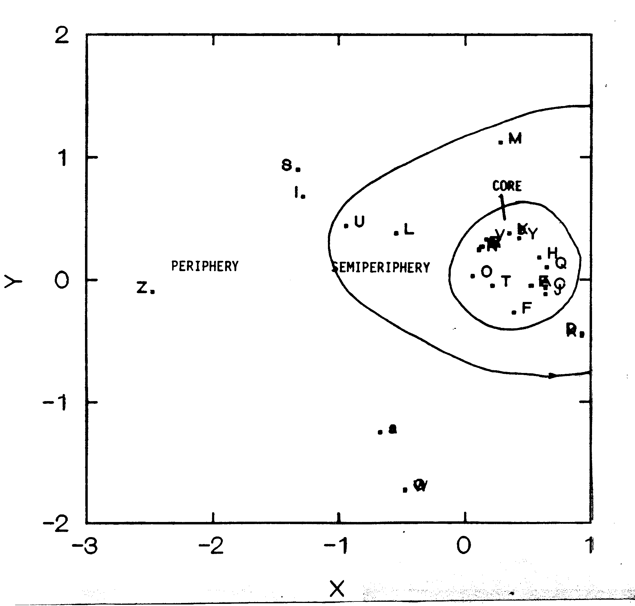
Figure 1. MDS of station opening successive pile sort data on “who hung-out with whom” for Year A.
Figure 2. MDS of station opening successive pile sort data on “who hung-out with whom” for Year B.
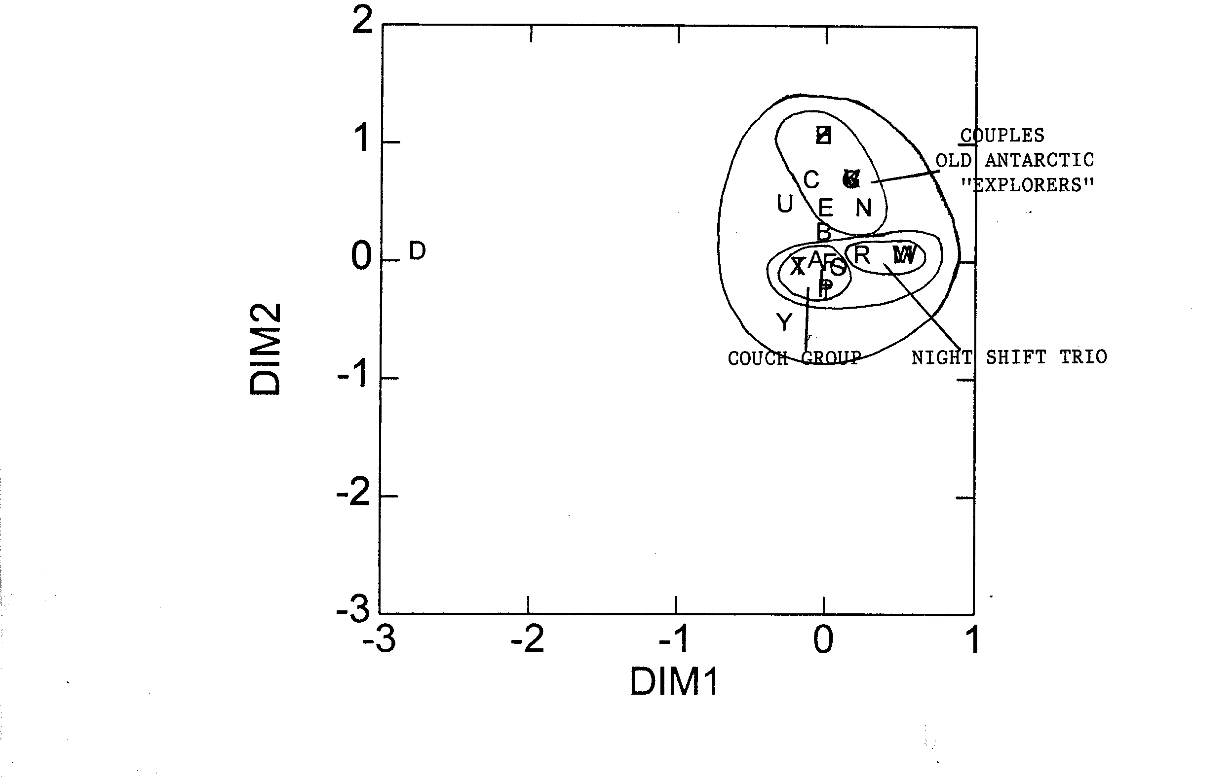
Figure 3. MDS of station opening successive pile sort data on “who hung-out with whom” for Year C.
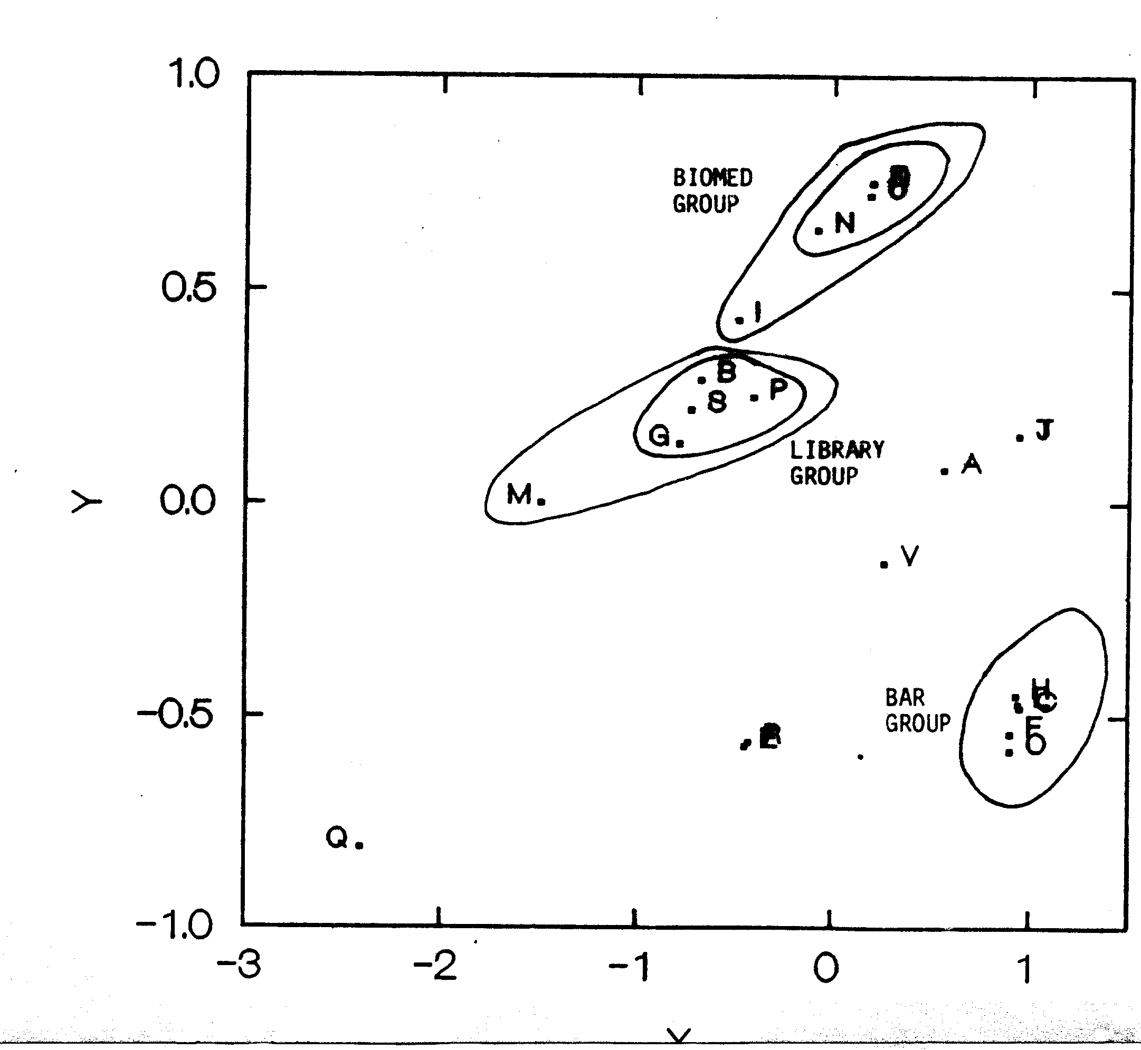
Figure 4. Comparisons of changes in final fitness over the course of the winter.
Figure 5. Correspondence analysis of the stacked social interaction matrices for the 8 months of winter showing actor’s initial position on March (beginning of vector) and final position in October (arrow) for Year A.
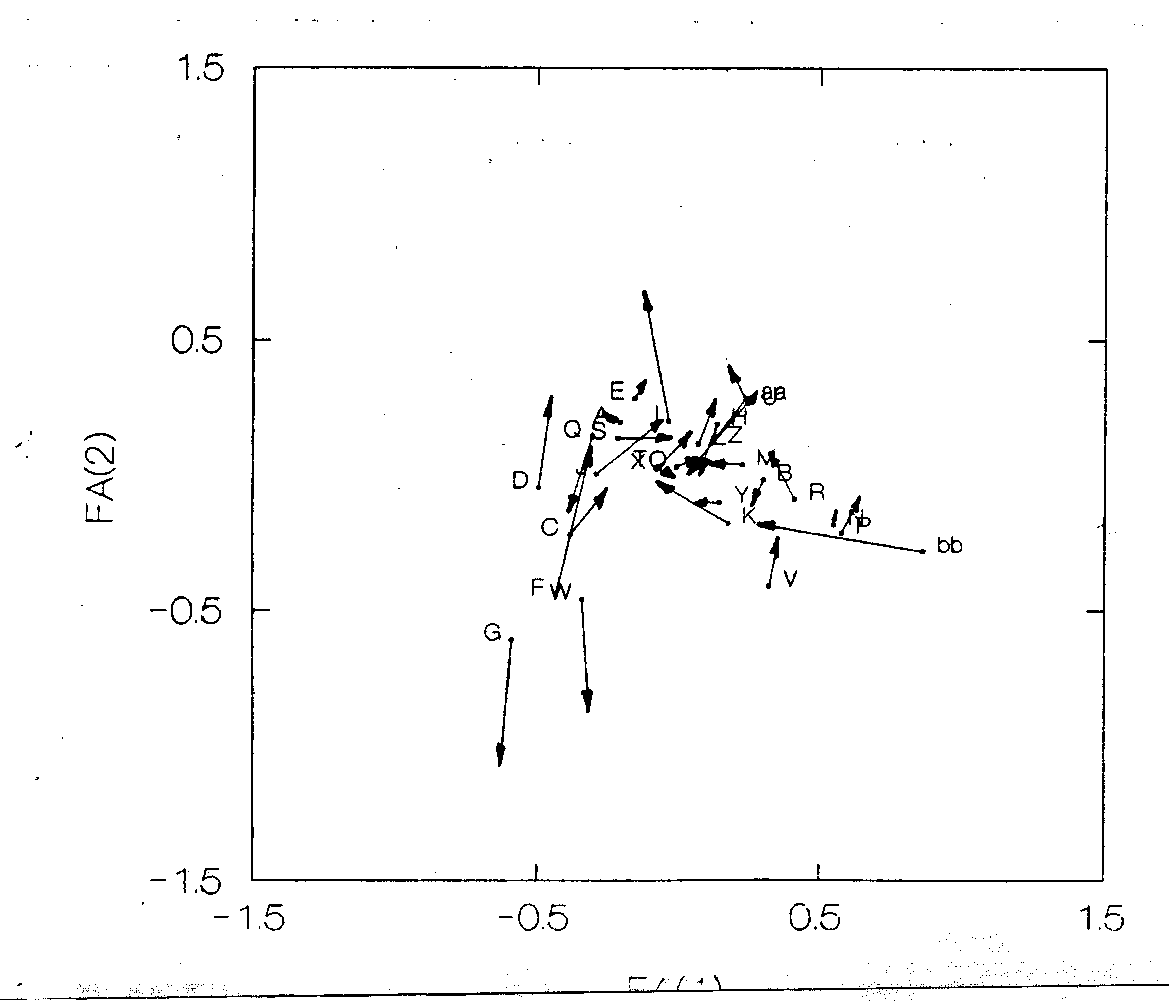
Figure 6. Correspondence analysis of the stacked social interaction matrices for the 8 months of winter showing actor’s initial position on March (beginning of vector) and final position in October (arrow) for Year B.
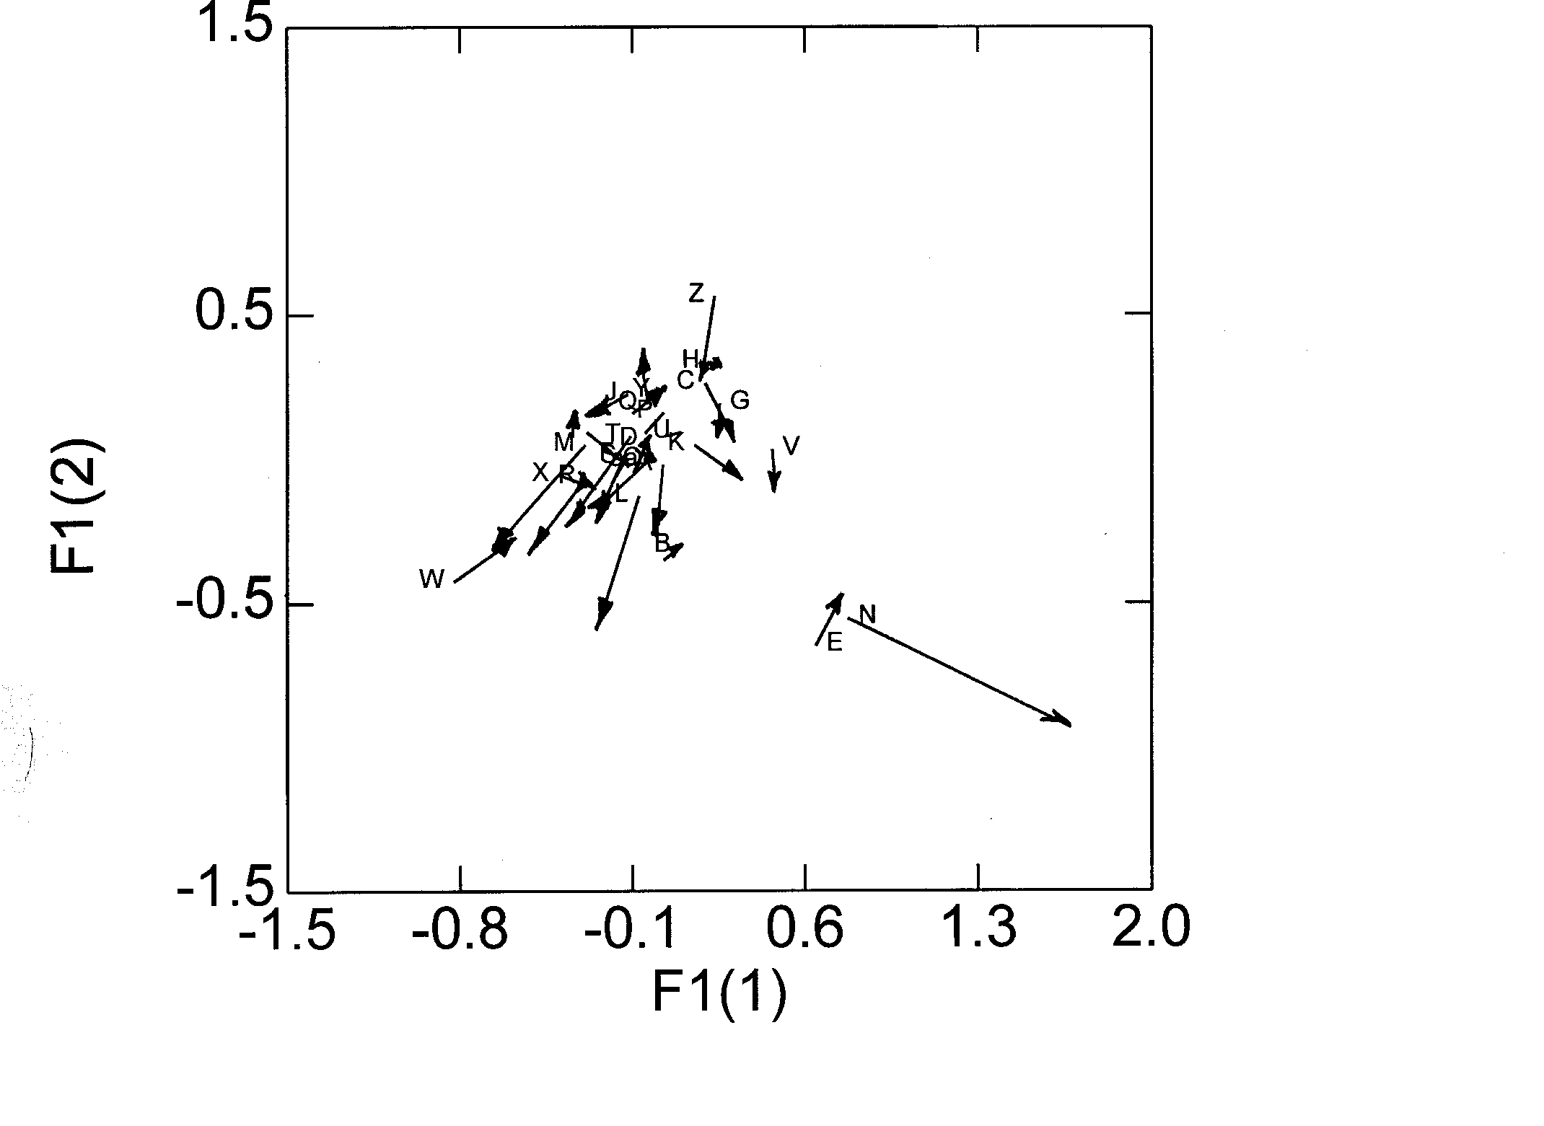
Figure 7. Correspondence analysis of the stacked social interaction matrices for the 8 months of winter showing actor’s initial position on March (beginning of vector) and final position in October (arrow) for Year C.
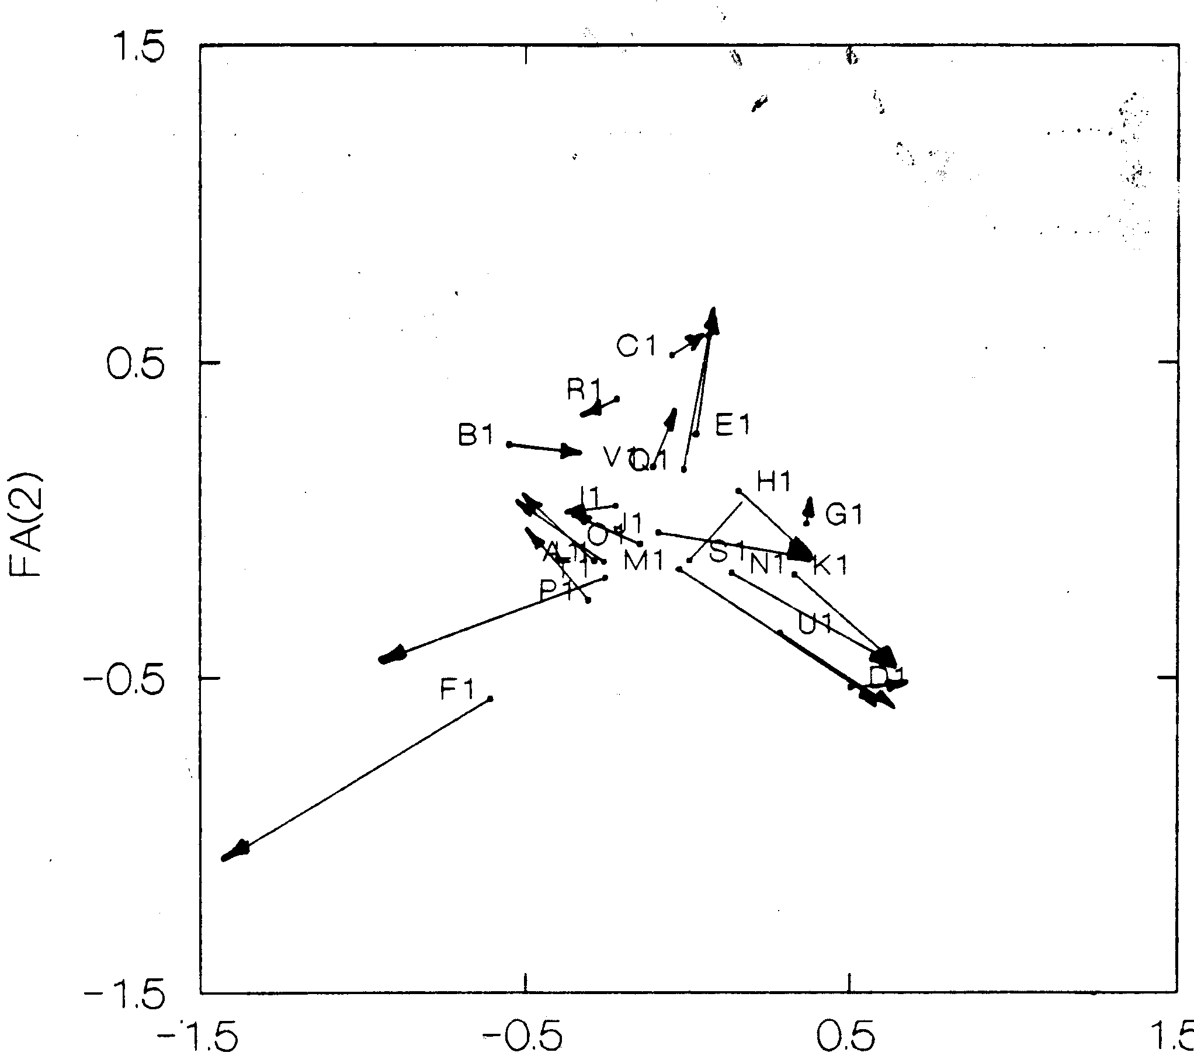
Figure 8. Graph of October (final) structure from stacked correspondence analysis showing the position of the manager (white vertice) in Year A.
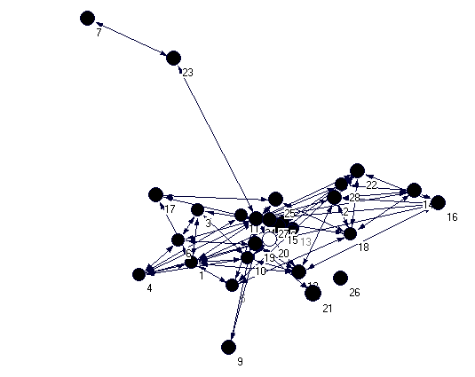
Figure 9. Graph of October (final) structure from stacked correspondence analysis showing the position of the manager (white vertice) in Year B.

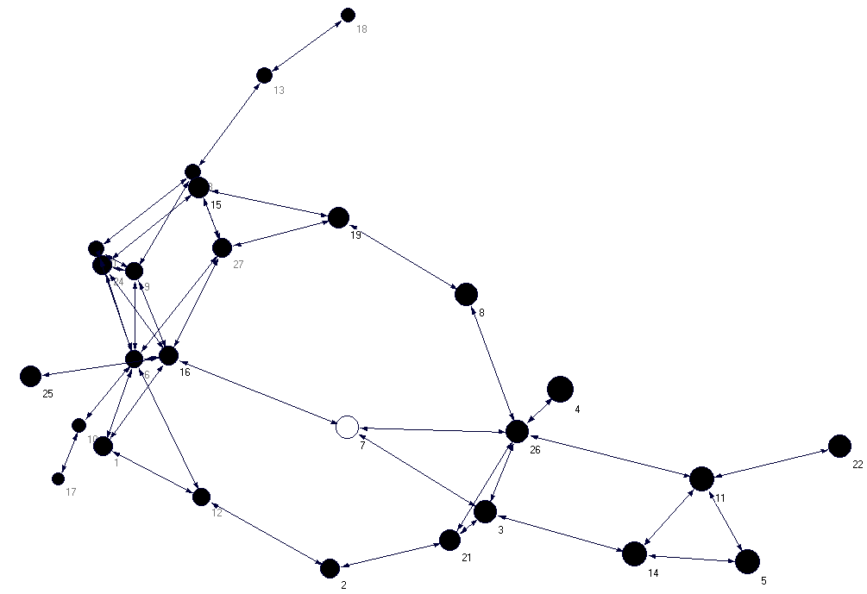
Figure 10. Graph of October (final) structure from stacked correspondence analysis showing the position of the manager (white vertice) in Year C.
