Centrality Lab

For this lab we will use 3 datasets:

WIRING:
This is a stacked dataset that includes many different files. We will be working with RDGAM. This is a dichotomous adjacency matrix of 14 employees of the bank wiring room of Western Electric. Ties are symmetric and represent participation in games during work breaks.

PRISON:
This is a dichotomous adjacency matrix of 67 prisoners. Ties are directed and represent each ego’s friends. Each was free to choose as few or as many "friends" as he desired.

DRUGNET:
This is a dichotomous adjacency matrix of drug users in Hartford. Ties are directed and represent the lending of drug needles. We will also work with the attribute file DRUGATTR.

REMINDER: Make sure that when you start UCINET your default folder (on the bottom of the screen) is set to the M: drive (typically, M:\DataFiles).

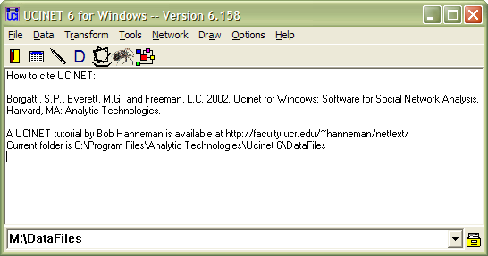

If it does not say M:\DataFiles on your machine, click the file drawer on the right ^ to change the default directory before starting the exercise.

EXERCISES:
- Centrality using UCINET and NetDraw with RDGAM
If you have not done so already use UCINET to unpack WIRING

a) Open RDGAM in Netdraw to familiarize yourself with the data
In UCINET calculate the following measures of cohesion using
Network | Centrality
Degree
Betweeness
Closeness
Eigenvector

- Using your Netdraw visualization, compare your calculations of various Centrality measures

- Now run Centrality multiple measures in UCINET using Network | Centrality | Multiple measures

- Compare the profile of W1 with W5 across all measures. Note that W1 is stronger in eigenvector while W5 is stronger on betweenness. Interpret this result

- Compare W5 with W7. They have same degree yet differ on eigenvector centrality. Why is W7 so much weaker on eigenvector centrality?

- Remove isolates using Data | Remove Isolates on RDGAM and \recalculate centrality measures
- Compare the results for closeness centrality (especially the descriptive statistics) with those from the previous run.
- Directed Centrality using UCINET with PRISON

a) Open PRISON in Netdraw to familiarize yourself with the data

b) Using UCINET calculate Centrality measures

c) Identify which individuals have the most friends in this dataset

3) Directed Centrality using NetDraw with PRISON

a) Open PRISON in Netdraw

b) Using NetDraw calculate Centrality measures under Analysis | Centrality

c) Resize the nodes based on various Centrality measures

d) Identify which individuals list the most number of friends

e) Identify which individuals are listed as friends by the most number of others

4) Directed Centrality using UCINET with DRUGNET

- Open DRUGNET in NetDraw to familiarize yourself with the data

- Using UCINET identify which individuals are at highest risk of contracting a disease based on their needle sharing habits

- In NetDraw, open DRUGATTR by clicking on the folder with the A

- Calculate Centrality measures in NetDraw (remember that this is directed data)

- Using NetDraw color the nodes based on different attributes and size the nodes based on different Centrality measures. Do you see any patterns?

ADVANCED

Using the RDGAM dataset from WIRING, create a file with four measures of centrality (the non-normalized versions of Degree, Betweenness, Closeness, and Eigenvector). To do this, you will use the Extract and Join commands under the Data Menu.

Then, run Degree Multiple Measures.

Create one correlation table for the four measures from the file you created manually and another for the file created from the multiple measures command.

How are the correlation tables the same and/or different? Explain.

